## Lead Assignment

In [1]:

**import** pandas **as** pd**import** numpy **as** np**import** warningswarnings**.**filterwarnings('ignore')**import** matplotlib.pyplot **as** plt**import** seaborn **as** sns

In [2]:

Lead_data **=** pd**.**read_csv("E:/upgrade/Lead Assignment/Lead Scoring Assignment/Leads.csv")Lead_data**.**head()

Out[2]:

|  | **Prospect ID** | **Lead Number** | **Lead Origin** | **Lead Source** | **Do Not Email** | **Do Not Call** | **Converted** | **TotalVisits** | **Total Time Spent on Website** | **Page Views Per Visit** | **...** | **Get updates on DM Content** | **Lead Profile** | **City** | **Asymmetrique Activity Index** | **Asymmetrique Profile Index** | **Asymmetrique Activity Score** | **Asymmetrique Profile Score** | **I agree to pay the amount through cheque** | **A free copy of Mastering The Interview** | **Last Notable Activity** |
| --- | --- | --- | --- | --- | --- | --- | --- | --- | --- | --- | --- | --- | --- | --- | --- | --- | --- | --- | --- | --- | --- |
| **0** | 7927b2df-8bba-4d29-b9a2-b6e0beafe620 | 660737 | API | Olark Chat | No | No | 0 | 0.0 | 0 | 0.0 | ... | No | Select | Select | 02.Medium | 02.Medium | 15.0 | 15.0 | No | No | Modified |
| **1** | 2a272436-5132-4136-86fa-dcc88c88f482 | 660728 | API | Organic Search | No | No | 0 | 5.0 | 674 | 2.5 | ... | No | Select | Select | 02.Medium | 02.Medium | 15.0 | 15.0 | No | No | Email Opened |
| **2** | 8cc8c611-a219-4f35-ad23-fdfd2656bd8a | 660727 | Landing Page Submission | Direct Traffic | No | No | 1 | 2.0 | 1532 | 2.0 | ... | No | Potential Lead | Mumbai | 02.Medium | 01.High | 14.0 | 20.0 | No | Yes | Email Opened |
| **3** | 0cc2df48-7cf4-4e39-9de9-19797f9b38cc | 660719 | Landing Page Submission | Direct Traffic | No | No | 0 | 1.0 | 305 | 1.0 | ... | No | Select | Mumbai | 02.Medium | 01.High | 13.0 | 17.0 | No | No | Modified |
| **4** | 3256f628-e534-4826-9d63-4a8b88782852 | 660681 | Landing Page Submission | Google | No | No | 1 | 2.0 | 1428 | 1.0 | ... | No | Select | Mumbai | 02.Medium | 01.High | 15.0 | 18.0 | No | No | Modified |

5 rows × 37 columns

In [3]:

Lead_data**.**describe()

Out[3]:

|  | **Lead Number** | **Converted** | **TotalVisits** | **Total Time Spent on Website** | **Page Views Per Visit** | **Asymmetrique Activity Score** | **Asymmetrique Profile Score** |
| --- | --- | --- | --- | --- | --- | --- | --- |
| **count** | 9240.000000 | 9240.000000 | 9103.000000 | 9240.000000 | 9103.000000 | 5022.000000 | 5022.000000 |
| **mean** | 617188.435606 | 0.385390 | 3.445238 | 487.698268 | 2.362820 | 14.306252 | 16.344883 |
| **std** | 23405.995698 | 0.486714 | 4.854853 | 548.021466 | 2.161418 | 1.386694 | 1.811395 |
| **min** | 579533.000000 | 0.000000 | 0.000000 | 0.000000 | 0.000000 | 7.000000 | 11.000000 |
| **25%** | 596484.500000 | 0.000000 | 1.000000 | 12.000000 | 1.000000 | 14.000000 | 15.000000 |
| **50%** | 615479.000000 | 0.000000 | 3.000000 | 248.000000 | 2.000000 | 14.000000 | 16.000000 |
| **75%** | 637387.250000 | 1.000000 | 5.000000 | 936.000000 | 3.000000 | 15.000000 | 18.000000 |
| **max** | 660737.000000 | 1.000000 | 251.000000 | 2272.000000 | 55.000000 | 18.000000 | 20.000000 |

In [4]:

Lead_data**.**info()

<class 'pandas.core.frame.DataFrame'>

RangeIndex: 9240 entries, 0 to 9239

Data columns (total 37 columns):

# Column Non-Null Count Dtype

--- ------ -------------- -----

0 Prospect ID 9240 non-null object

1 Lead Number 9240 non-null int64

2 Lead Origin 9240 non-null object

3 Lead Source 9204 non-null object

4 Do Not Email 9240 non-null object

5 Do Not Call 9240 non-null object

6 Converted 9240 non-null int64

7 TotalVisits 9103 non-null float64

8 Total Time Spent on Website 9240 non-null int64

9 Page Views Per Visit 9103 non-null float64

10 Last Activity 9137 non-null object

11 Country 6779 non-null object

12 Specialization 7802 non-null object

13 How did you hear about X Education 7033 non-null object

14 What is your current occupation 6550 non-null object

15 What matters most to you in choosing a course 6531 non-null object

16 Search 9240 non-null object

17 Magazine 9240 non-null object

18 Newspaper Article 9240 non-null object

19 X Education Forums 9240 non-null object

20 Newspaper 9240 non-null object

21 Digital Advertisement 9240 non-null object

22 Through Recommendations 9240 non-null object

23 Receive More Updates About Our Courses 9240 non-null object

24 Tags 5887 non-null object

25 Lead Quality 4473 non-null object

26 Update me on Supply Chain Content 9240 non-null object

27 Get updates on DM Content 9240 non-null object

28 Lead Profile 6531 non-null object

29 City 7820 non-null object

30 Asymmetrique Activity Index 5022 non-null object

31 Asymmetrique Profile Index 5022 non-null object

32 Asymmetrique Activity Score 5022 non-null float64

33 Asymmetrique Profile Score 5022 non-null float64

34 I agree to pay the amount through cheque 9240 non-null object

35 A free copy of Mastering The Interview 9240 non-null object

36 Last Notable Activity 9240 non-null object

dtypes: float64(4), int64(3), object(30)

memory usage: 2.6+ MB

In [5]:

Lead_data**.**shape

Out[5]:

(9240, 37)

In [ ]:

In [6]:

*# check for duplicate* Lead_data**.**duplicated(subset **=** ['Prospect ID'], keep **=** **False**)**.**sum()

Out[6]:

0

In [7]:

Lead_data**.**duplicated(subset **=** ['Lead Number'], keep **=** **False**)**.**sum()

Out[7]:

0

No duplicate values in Prospect ID and Lead Number

Clearly Prospect ID & Lead Number are two variables that are just indicative of the ID number of the Contacted People & can be dropped.

## EXPLORATORY DATA ANALYSIS

### Data Cleaning & Treatment:

In [8]:

*#dropping Lead Number and Prospect ID since they have all unique values*

Lead_data**.**drop(['Prospect ID', 'Lead Number'], 1, inplace **=** **True**)

In [9]:

*#Converting 'Select' values to NaN.*

Lead_data **=** Lead_data**.**replace('Select', np**.**nan)

In [10]:

Lead_data**.**nunique()

Out[10]:

Lead Origin 5

Lead Source 21

Do Not Email 2

Do Not Call 2

Converted 2

TotalVisits 41

Total Time Spent on Website 1731

Page Views Per Visit 114

Last Activity 17

Country 38

Specialization 18

How did you hear about X Education 9

What is your current occupation 6

What matters most to you in choosing a course 3

Search 2

Magazine 1

Newspaper Article 2

X Education Forums 2

Newspaper 2

Digital Advertisement 2

Through Recommendations 2

Receive More Updates About Our Courses 1

Tags 26

Lead Quality 5

Update me on Supply Chain Content 1

Get updates on DM Content 1

Lead Profile 5

City 6

Asymmetrique Activity Index 3

Asymmetrique Profile Index 3

Asymmetrique Activity Score 12

Asymmetrique Profile Score 10

I agree to pay the amount through cheque 1

A free copy of Mastering The Interview 2

Last Notable Activity 16

dtype: int64

In [11]:

*# Dropping unique valued columns*Lead_data**=** Lead_data**.**drop(['Magazine','Receive More Updates About Our Courses','I agree to pay the amount through cheque','Get updates on DM Content','Update me on Supply Chain Content'],axis**=**1)

In [12]:

*#checking null values in each rows*

Lead_data**.**isnull()**.**sum()

Out[12]:

Lead Origin 0

Lead Source 36

Do Not Email 0

Do Not Call 0

Converted 0

TotalVisits 137

Total Time Spent on Website 0

Page Views Per Visit 137

Last Activity 103

Country 2461

Specialization 3380

How did you hear about X Education 7250

What is your current occupation 2690

What matters most to you in choosing a course 2709

Search 0

Newspaper Article 0

X Education Forums 0

Newspaper 0

Digital Advertisement 0

Through Recommendations 0

Tags 3353

Lead Quality 4767

Lead Profile 6855

City 3669

Asymmetrique Activity Index 4218

Asymmetrique Profile Index 4218

Asymmetrique Activity Score 4218

Asymmetrique Profile Score 4218

A free copy of Mastering The Interview 0

Last Notable Activity 0

dtype: int64

In [13]:

*# % of null value*round(100**\***(Lead_data**.**isnull()**.**sum())**/**len(Lead_data**.**index),2)

Out[13]:

Lead Origin 0.00

Lead Source 0.39

Do Not Email 0.00

Do Not Call 0.00

Converted 0.00

TotalVisits 1.48

Total Time Spent on Website 0.00

Page Views Per Visit 1.48

Last Activity 1.11

Country 26.63

Specialization 36.58

How did you hear about X Education 78.46

What is your current occupation 29.11

What matters most to you in choosing a course 29.32

Search 0.00

Newspaper Article 0.00

X Education Forums 0.00

Newspaper 0.00

Digital Advertisement 0.00

Through Recommendations 0.00

Tags 36.29

Lead Quality 51.59

Lead Profile 74.19

City 39.71

Asymmetrique Activity Index 45.65

Asymmetrique Profile Index 45.65

Asymmetrique Activity Score 45.65

Asymmetrique Profile Score 45.65

A free copy of Mastering The Interview 0.00

Last Notable Activity 0.00

dtype: float64

In [14]:

*#dropping cols with more than 45% missing values*

Lead_data **=** Lead_data**.**drop(['Asymmetrique Profile Score','Asymmetrique Activity Score','Asymmetrique Profile Index','Asymmetrique Activity Index','Lead Profile','Lead Quality','How did you hear about X Education',],axis **=**1)

In [15]:

Lead_data**.**shape

Out[15]:

(9240, 23)

In [16]:

*#checking null values percentage*

round(100**\***(Lead_data**.**isnull()**.**sum()**/**len(Lead_data**.**index)), 2)

Out[16]:

Lead Origin 0.00

Lead Source 0.39

Do Not Email 0.00

Do Not Call 0.00

Converted 0.00

TotalVisits 1.48

Total Time Spent on Website 0.00

Page Views Per Visit 1.48

Last Activity 1.11

Country 26.63

Specialization 36.58

What is your current occupation 29.11

What matters most to you in choosing a course 29.32

Search 0.00

Newspaper Article 0.00

X Education Forums 0.00

Newspaper 0.00

Digital Advertisement 0.00

Through Recommendations 0.00

Tags 36.29

City 39.71

A free copy of Mastering The Interview 0.00

Last Notable Activity 0.00

dtype: float64

There is a huge value of null variables in some columns as seen above. But removing the rows with the null value will cost us a lot of data and they are important columns. So, instead we are going to replace the NaN values with 'not provided'. This way we have all the data and almost no null values. In case these come up in the model, it will be of no use and we can drop it off then.

In [17]:

Lead_data['Specialization'] **=** Lead_data['Specialization']**.**fillna('not provided')Lead_data['City'] **=** Lead_data['City']**.**fillna('not provided')Lead_data['Tags'] **=** Lead_data['Tags']**.**fillna('not provided')Lead_data['What matters most to you in choosing a course'] **=** Lead_data['What matters most to you in choosing a course']**.**fillna('not provided')Lead_data['What is your current occupation'] **=** Lead_data['What is your current occupation']**.**fillna('not provided')Lead_data['Country'] **=** Lead_data['Country']**.**fillna('not provided')Lead_data**.**info()

<class 'pandas.core.frame.DataFrame'>

RangeIndex: 9240 entries, 0 to 9239

Data columns (total 23 columns):

# Column Non-Null Count Dtype

--- ------ -------------- -----

0 Lead Origin 9240 non-null object

1 Lead Source 9204 non-null object

2 Do Not Email 9240 non-null object

3 Do Not Call 9240 non-null object

4 Converted 9240 non-null int64

5 TotalVisits 9103 non-null float64

6 Total Time Spent on Website 9240 non-null int64

7 Page Views Per Visit 9103 non-null float64

8 Last Activity 9137 non-null object

9 Country 9240 non-null object

10 Specialization 9240 non-null object

11 What is your current occupation 9240 non-null object

12 What matters most to you in choosing a course 9240 non-null object

13 Search 9240 non-null object

14 Newspaper Article 9240 non-null object

15 X Education Forums 9240 non-null object

16 Newspaper 9240 non-null object

17 Digital Advertisement 9240 non-null object

18 Through Recommendations 9240 non-null object

19 Tags 9240 non-null object

20 City 9240 non-null object

21 A free copy of Mastering The Interview 9240 non-null object

22 Last Notable Activity 9240 non-null object

dtypes: float64(2), int64(2), object(19)

memory usage: 1.6+ MB

In [18]:

*#checking null values percentage*

round(100**\***(Lead_data**.**isnull()**.**sum()**/**len(Lead_data**.**index)), 2)

Out[18]:

Lead Origin 0.00

Lead Source 0.39

Do Not Email 0.00

Do Not Call 0.00

Converted 0.00

TotalVisits 1.48

Total Time Spent on Website 0.00

Page Views Per Visit 1.48

Last Activity 1.11

Country 0.00

Specialization 0.00

What is your current occupation 0.00

What matters most to you in choosing a course 0.00

Search 0.00

Newspaper Article 0.00

X Education Forums 0.00

Newspaper 0.00

Digital Advertisement 0.00

Through Recommendations 0.00

Tags 0.00

City 0.00

A free copy of Mastering The Interview 0.00

Last Notable Activity 0.00

dtype: float64

In [19]:

Lead_data**.**shape

Out[19]:

(9240, 23)

### Categorical Attributes Analysis:

In [20]:

Lead_data['Country']**.**value_counts()

Out[20]:

India 6492

not provided 2461

United States 69

United Arab Emirates 53

Singapore 24

Saudi Arabia 21

United Kingdom 15

Australia 13

Qatar 10

Bahrain 7

Hong Kong 7

France 6

Oman 6

unknown 5

Canada 4

South Africa 4

Nigeria 4

Kuwait 4

Germany 4

Sweden 3

Ghana 2

Uganda 2

Italy 2

Bangladesh 2

Philippines 2

China 2

Netherlands 2

Belgium 2

Asia/Pacific Region 2

Russia 1

Kenya 1

Liberia 1

Denmark 1

Sri Lanka 1

Switzerland 1

Vietnam 1

Tanzania 1

Malaysia 1

Indonesia 1

Name: Country, dtype: int64

In [21]:

**def** slots(x):

category **=** ""

**if** x **==** "India":

category **=** "India"

**elif** x **==** "not provided":

category **=** "not provided"

**else**:

category **=** "outside india"

**return** category

Lead_data['Country'] **=** Lead_data**.**apply(**lambda** x:slots(x['Country']), axis **=** 1)Lead_data['Country']**.**value_counts()

Out[21]:

India 6492

not provided 2461

outside india 287

Name: Country, dtype: int64

In [22]:

*# Since India is the most common occurence among the non-missing values we can impute all not provided values with India*

Lead_data['Country'] **=** Lead_data['Country']**.**replace('not provided','India')Lead_data['Country']**.**value_counts()

Out[22]:

India 8953

outside india 287

Name: Country, dtype: int64

In [23]:

*# Checking the percent of lose if the null values are removed*round(100**\***(sum(Lead_data**.**isnull()**.**sum(axis**=**1) **>** 1)**/**Lead_data**.**shape[0]),2)

Out[23]:

1.48

In [24]:

Lead_data **=** Lead_data[Lead_data**.**isnull()**.**sum(axis**=**1) **<**1]

In [25]:

*# Rechecking the percentage of missing values*round(100**\***(Lead_data**.**isnull()**.**sum()**/**len(Lead_data**.**index)), 2)

Out[25]:

Lead Origin 0.0

Lead Source 0.0

Do Not Email 0.0

Do Not Call 0.0

Converted 0.0

TotalVisits 0.0

Total Time Spent on Website 0.0

Page Views Per Visit 0.0

Last Activity 0.0

Country 0.0

Specialization 0.0

What is your current occupation 0.0

What matters most to you in choosing a course 0.0

Search 0.0

Newspaper Article 0.0

X Education Forums 0.0

Newspaper 0.0

Digital Advertisement 0.0

Through Recommendations 0.0

Tags 0.0

City 0.0

A free copy of Mastering The Interview 0.0

Last Notable Activity 0.0

dtype: float64

In [26]:

Lead_data**.**shape

Out[26]:

(9074, 23)

In [27]:

*#plotting spread of Country columnn after replacing NaN values*

plt**.**figure(figsize**=**(15,5))s1**=**sns**.**countplot(Lead_data**.**Country, hue**=**Lead_data**.**Converted)s1**.**set_xticklabels(s1**.**get_xticklabels(),rotation**=**90)plt**.**show()

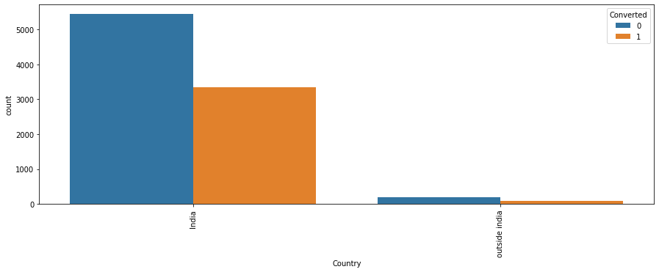

As we can see the Number of Values for India are quite high (nearly 97% of the Data), this column can be dropped

In [28]:

*#creating a list of columns to be droppped*

cols_to_drop**=**['Country']

In [29]:

*#checking value counts of "City" column*

Lead_data['City']**.**value_counts(dropna**=False**)

Out[29]:

not provided 3575

Mumbai 3177

Thane & Outskirts 745

Other Cities 680

Other Cities of Maharashtra 446

Other Metro Cities 377

Tier II Cities 74

Name: City, dtype: int64

In [30]:

*#plotting spread of City columnn*

plt**.**figure(figsize**=**(10,5))s1**=**sns**.**countplot(Lead_data**.**City, hue**=**Lead_data**.**Converted)s1**.**set_xticklabels(s1**.**get_xticklabels(),rotation**=**90)plt**.**show()

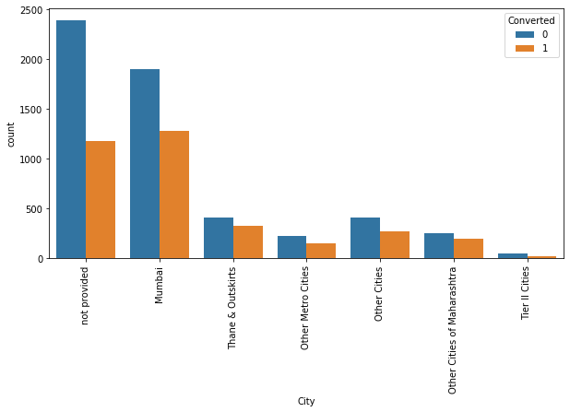

In [31]:

plt**.**figure(figsize **=** (20,40))

plt**.**subplot(6,2,1)sns**.**countplot(Lead_data['Lead Origin'])plt**.**title('Lead Origin')

plt**.**subplot(6,2,2)sns**.**countplot(Lead_data['Do Not Email'])plt**.**title('Do Not Email')

plt**.**subplot(6,2,3)sns**.**countplot(Lead_data['Do Not Call'])plt**.**title('Do Not Call')

plt**.**subplot(6,2,4)sns**.**countplot(Lead_data['Country'])plt**.**title('Country')

plt**.**subplot(6,2,5)sns**.**countplot(Lead_data['Search'])plt**.**title('Search')plt**.**subplot(6,2,6)sns**.**countplot(Lead_data['Newspaper Article'])plt**.**title('Newspaper Article')

plt**.**subplot(6,2,7)sns**.**countplot(Lead_data['X Education Forums'])plt**.**title('X Education Forums')

plt**.**subplot(6,2,8)sns**.**countplot(Lead_data['Newspaper'])plt**.**title('Newspaper')

plt**.**subplot(6,2,9)sns**.**countplot(Lead_data['Digital Advertisement'])plt**.**title('Digital Advertisement')

plt**.**subplot(6,2,10)sns**.**countplot(Lead_data['Through Recommendations'])plt**.**title('Through Recommendations')

plt**.**subplot(6,2,11)sns**.**countplot(Lead_data['A free copy of Mastering The Interview'])plt**.**title('A free copy of Mastering The Interview')plt**.**subplot(6,2,12)sns**.**countplot(Lead_data['Last Notable Activity'])**.**tick_params(axis**=**'x', rotation **=** 90)plt**.**title('Last Notable Activity')

plt**.**show()

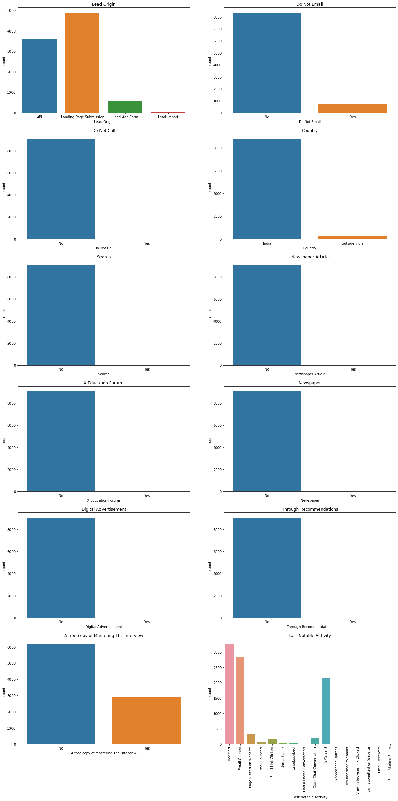

In [32]:

sns**.**countplot(Lead_data['Lead Source'])**.**tick_params(axis**=**'x', rotation **=** 90)plt**.**title('Lead Source')plt**.**show()

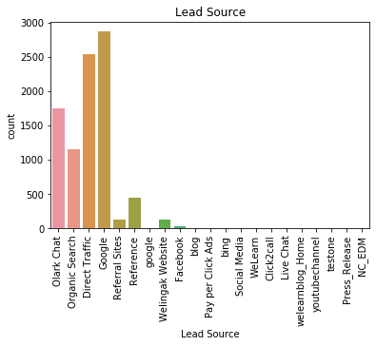

In [33]:

plt**.**figure(figsize **=** (20,30))plt**.**subplot(2,2,1)sns**.**countplot(Lead_data['Specialization'])**.**tick_params(axis**=**'x', rotation **=** 90)plt**.**title('Specialization')plt**.**subplot(2,2,2)sns**.**countplot(Lead_data['What is your current occupation'])**.**tick_params(axis**=**'x', rotation **=** 90)plt**.**title('Current Occupation')plt**.**subplot(2,2,3)sns**.**countplot(Lead_data['What matters most to you in choosing a course'])**.**tick_params(axis**=**'x', rotation **=** 90)plt**.**title('What matters most to you in choosing a course')plt**.**subplot(2,2,4)sns**.**countplot(Lead_data['Last Activity'])**.**tick_params(axis**=**'x', rotation **=** 90)plt**.**title('Last Activity')plt**.**show()

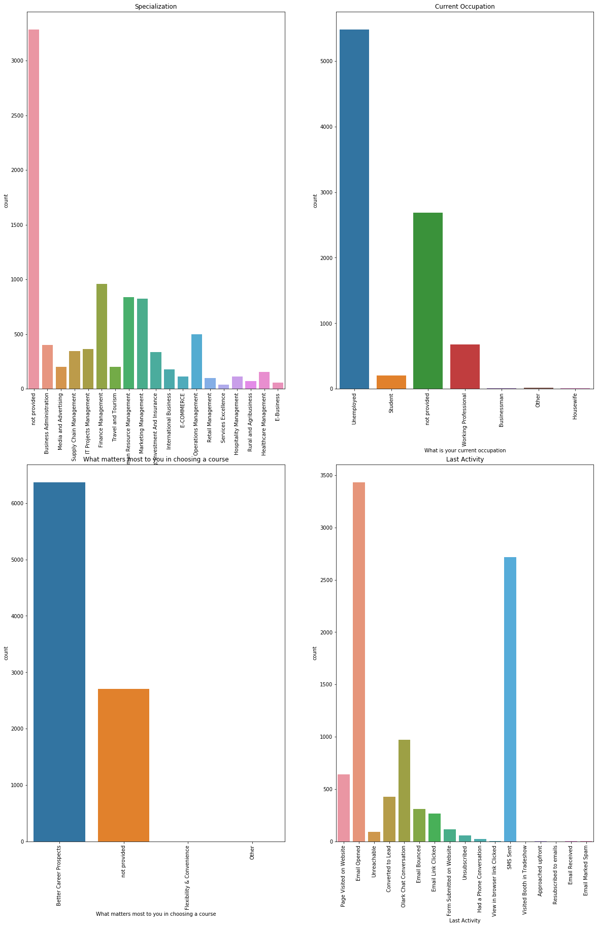

In [34]:

sns**.**countplot(Lead_data['Converted'])plt**.**title('Converted("Y variable")')plt**.**show()

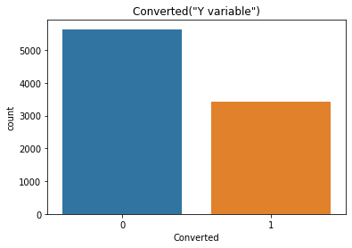

## Numerical Variables

In [35]:

plt**.**figure(figsize **=** (10,10))plt**.**subplot(221)plt**.**hist(Lead_data['TotalVisits'], bins **=** 200)plt**.**title('Total Visits')plt**.**xlim(0,25)

plt**.**subplot(222)plt**.**hist(Lead_data['Total Time Spent on Website'], bins **=** 10)plt**.**title('Total Time Spent on Website')

plt**.**subplot(223)plt**.**hist(Lead_data['Page Views Per Visit'], bins **=** 20)plt**.**title('Page Views Per Visit')plt**.**xlim(0,20)plt**.**show( )

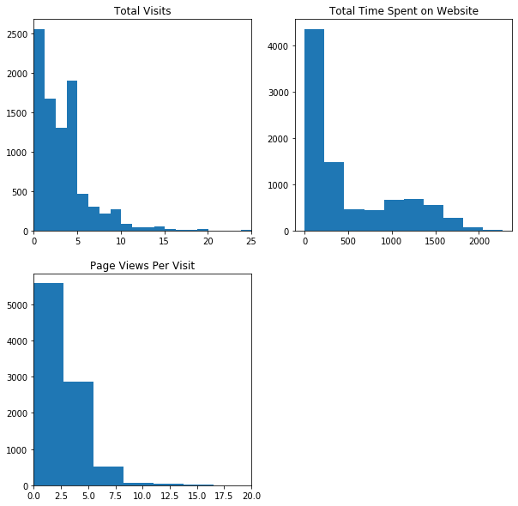

## Relating all the categorical variables to Converted

In [36]:

plt**.**figure(figsize **=** (10,10))

plt**.**subplot(2,2,1)sns**.**countplot(x**=**'Lead Origin', hue**=**'Converted', data**=** Lead_data)**.**tick_params(axis**=**'x', rotation **=** 90)plt**.**title('Lead Origin')

plt**.**subplot(2,2,2)sns**.**countplot(x**=**'Lead Source', hue**=**'Converted', data**=** Lead_data)**.**tick_params(axis**=**'x', rotation **=** 90)plt**.**title('Lead Source')plt**.**show()

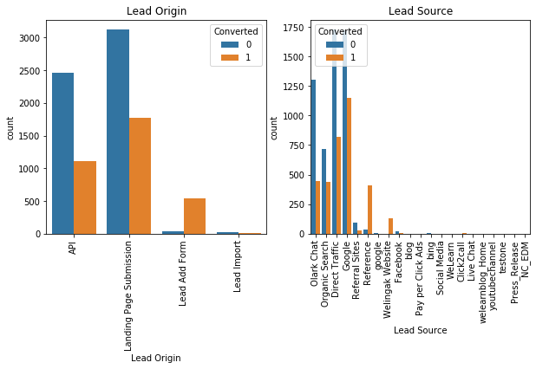

In [37]:

plt**.**figure(figsize**=**(10 ,5))plt**.**subplot(1,2,1)sns**.**countplot(x**=**'Do Not Email', hue**=**'Converted', data**=** Lead_data)**.**tick_params(axis**=**'x', rotation **=** 90)plt**.**title('Do Not Email')

plt**.**subplot(1,2,2)sns**.**countplot(x**=**'Do Not Call', hue**=**'Converted', data**=** Lead_data)**.**tick_params(axis**=**'x', rotation **=** 90)plt**.**title('Do Not Call')plt**.**show()

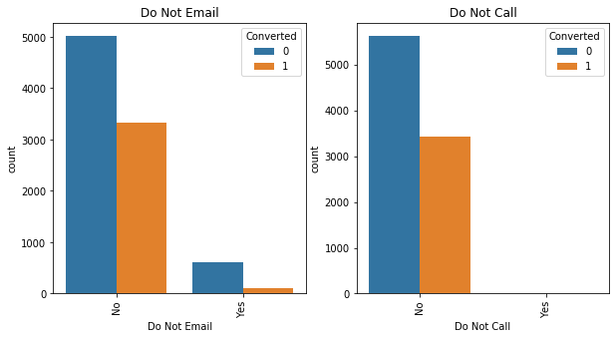

In [38]:

plt**.**figure(figsize **=** (10,5))

plt**.**subplot(1,2,1)sns**.**countplot(x**=**'Last Activity', hue**=**'Converted', data**=** Lead_data)**.**tick_params(axis**=**'x', rotation **=** 90)plt**.**title('Last Activity')

plt**.**subplot(1,2,2)sns**.**countplot(x**=**'Country', hue**=**'Converted', data**=** Lead_data)**.**tick_params(axis**=**'x', rotation **=** 90)plt**.**title('Country')plt**.**show()

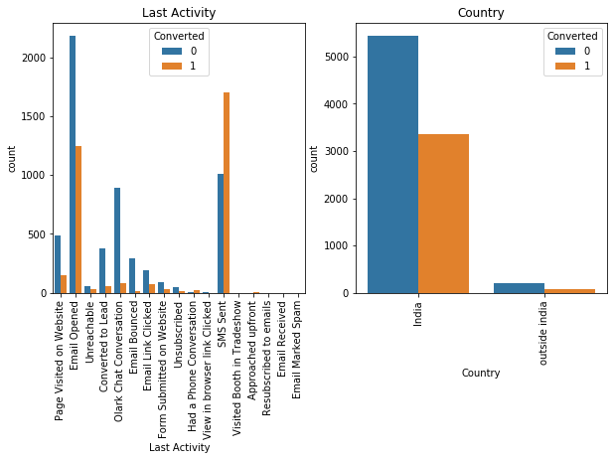

In [39]:

plt**.**figure(figsize **=** (10,5))

plt**.**subplot(1,2,1)sns**.**countplot(x**=**'Specialization', hue**=**'Converted', data**=** Lead_data)**.**tick_params(axis**=**'x', rotation **=** 90)plt**.**title('Specialization')

plt**.**subplot(1,2,2)sns**.**countplot(x**=**'What is your current occupation', hue**=**'Converted', data**=** Lead_data)**.**tick_params(axis**=**'x', rotation **=** 90)plt**.**title('What is your current occupation')plt**.**show()

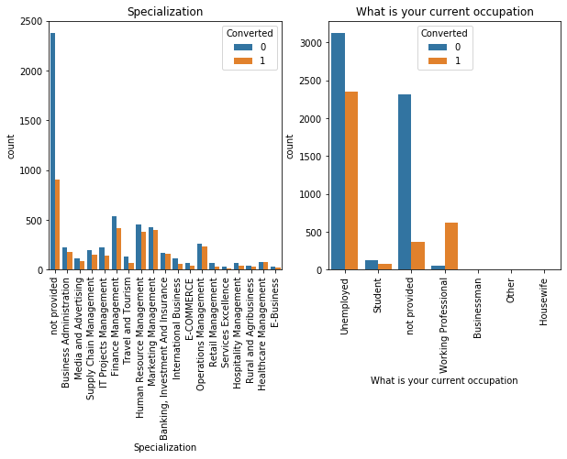

In [40]:

plt**.**figure(figsize **=** (10,5))

plt**.**subplot(1,2,1)sns**.**countplot(x**=**'What matters most to you in choosing a course', hue**=**'Converted', data**=** Lead_data)**.**tick_params(axis**=**'x', rotation **=** 90)plt**.**title('What matters most to you in choosing a course')

plt**.**subplot(1,2,2)sns**.**countplot(x**=**'Search', hue**=**'Converted', data**=** Lead_data)**.**tick_params(axis**=**'x', rotation **=** 90)plt**.**title('Search')plt**.**show()

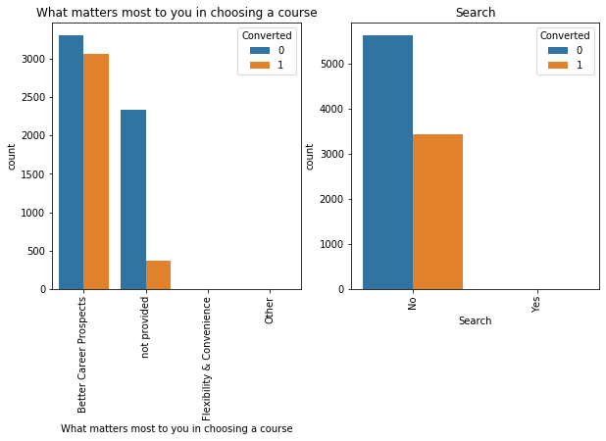

In [41]:

plt**.**figure(figsize **=** (10,5))

plt**.**subplot(1,2,1)sns**.**countplot(x**=**'Newspaper Article', hue**=**'Converted', data**=** Lead_data)**.**tick_params(axis**=**'x', rotation **=** 90)plt**.**title('Newspaper Article')

plt**.**subplot(1,2,2)sns**.**countplot(x**=**'X Education Forums', hue**=**'Converted', data**=** Lead_data)**.**tick_params(axis**=**'x', rotation **=** 90)plt**.**title('X Education Forums')plt**.**show()

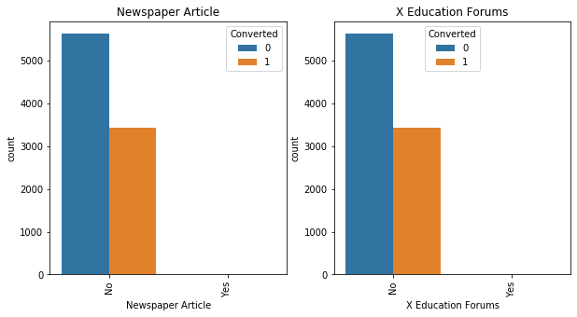

In [42]:

plt**.**figure(figsize **=** (10,5))

plt**.**subplot(1,2,1)sns**.**countplot(x**=**'Newspaper', hue**=**'Converted', data**=** Lead_data)**.**tick_params(axis**=**'x', rotation **=** 90)plt**.**title('Newspaper')

plt**.**subplot(1,2,2)sns**.**countplot(x**=**'Digital Advertisement', hue**=**'Converted', data**=** Lead_data)**.**tick_params(axis**=**'x', rotation **=** 90)plt**.**title('Digital Advertisement')plt**.**show()

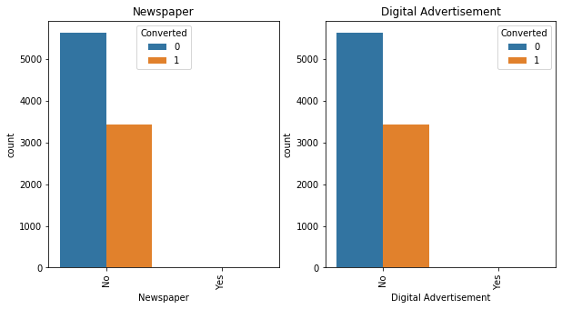

In [43]:

plt**.**figure(figsize **=** (10,5))

plt**.**subplot(1,2,1)sns**.**countplot(x**=**'Through Recommendations', hue**=**'Converted', data**=** Lead_data)**.**tick_params(axis**=**'x', rotation **=** 90)plt**.**title('Through Recommendations')

plt**.**subplot(1,2,2)sns**.**countplot(x**=**'A free copy of Mastering The Interview', hue**=**'Converted', data**=** Lead_data)**.**tick_params(axis**=**'x', rotation **=** 90)plt**.**title('A free copy of Mastering The Interview')plt**.**show()

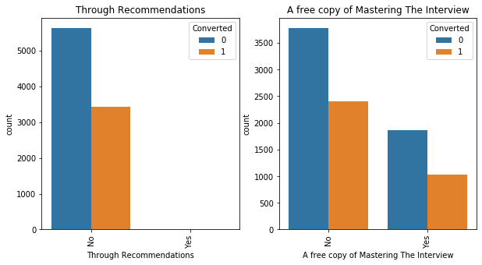

In [44]:

sns**.**countplot(x**=**'Last Notable Activity', hue**=**'Converted', data**=** Lead_data)**.**tick_params(axis**=**'x', rotation **=** 90)plt**.**title('Last Notable Activity')plt**.**show()

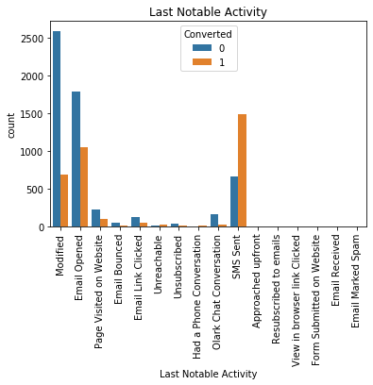

In [45]:

*# To check the correlation among varibles*plt**.**figure(figsize**=**(10,5))sns**.**heatmap(Lead_data**.**corr())plt**.**show()

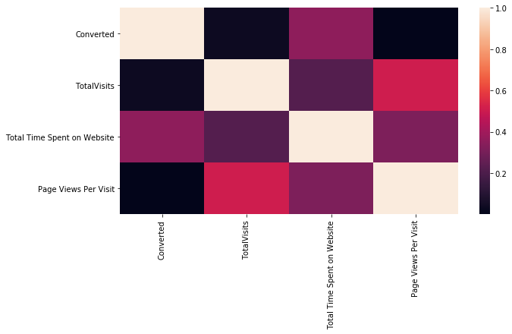

It is understandable from the above EDA that there are many elements that have very little data and so will be of less relevance to our analysis.

## Outlier

In [46]:

numeric **=** Lead_data[['TotalVisits','Total Time Spent on Website','Page Views Per Visit']]numeric**.**describe(percentiles**=**[0.25,0.5,0.75,0.9,0.99])

Out[46]:

|  | **TotalVisits** | **Total Time Spent on Website** | **Page Views Per Visit** |
| --- | --- | --- | --- |
| **count** | 9074.000000 | 9074.000000 | 9074.000000 |
| **mean** | 3.456028 | 482.887481 | 2.370151 |
| **std** | 4.858802 | 545.256560 | 2.160871 |
| **min** | 0.000000 | 0.000000 | 0.000000 |
| **25%** | 1.000000 | 11.000000 | 1.000000 |
| **50%** | 3.000000 | 246.000000 | 2.000000 |
| **75%** | 5.000000 | 922.750000 | 3.200000 |
| **90%** | 7.000000 | 1373.000000 | 5.000000 |
| **99%** | 17.000000 | 1839.000000 | 9.000000 |
| **max** | 251.000000 | 2272.000000 | 55.000000 |

In [47]:

plt**.**figure(figsize **=** (5,5))sns**.**boxplot(y**=**Lead_data['TotalVisits'])plt**.**show()

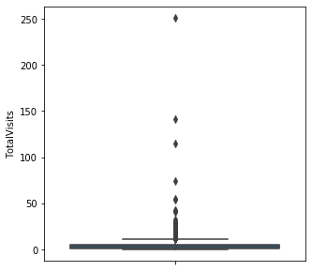

In [48]:

sns**.**boxplot(y**=**Lead_data['Total Time Spent on Website'])plt**.**show()

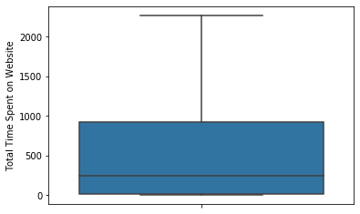

In [49]:

sns**.**boxplot(y**=**Lead_data['Page Views Per Visit'])plt**.**show()

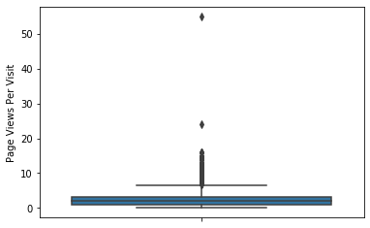

We can see presence of outliers in TotalVisits

In [50]:

*#Outlier Treatment: Remove top & bottom 1% of the Column Outlier values*

Q3 **=** Lead_data**.**TotalVisits**.**quantile(0.99)Lead_data **=** Lead_data[(Lead_data**.**TotalVisits **<=** Q3)]Q1 **=** Lead_data**.**TotalVisits**.**quantile(0.01)Lead_data **=** Lead_data[(Lead_data**.**TotalVisits **>=** Q1)]sns**.**boxplot(y**=**Lead_data['TotalVisits'])plt**.**show()

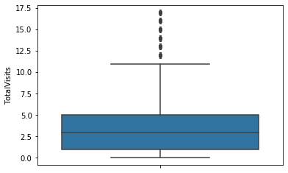

## Dummy Variables

In [ ]:

In [51]:

*#list of columns to be dropped*cols_to_drop**=**['Country','Tags']

We can drop "Tags" ,As tags variable is generated by the sales sales team after the disscussion with student otherwise it will increase the model accuracy .

In [52]:

*#dropping columns*Lead_data **=** Lead_data**.**drop(cols_to_drop,1)Lead_data**.**info()

<class 'pandas.core.frame.DataFrame'>

Int64Index: 8991 entries, 0 to 9239

Data columns (total 21 columns):

# Column Non-Null Count Dtype

--- ------ -------------- -----

0 Lead Origin 8991 non-null object

1 Lead Source 8991 non-null object

2 Do Not Email 8991 non-null object

3 Do Not Call 8991 non-null object

4 Converted 8991 non-null int64

5 TotalVisits 8991 non-null float64

6 Total Time Spent on Website 8991 non-null int64

7 Page Views Per Visit 8991 non-null float64

8 Last Activity 8991 non-null object

9 Specialization 8991 non-null object

10 What is your current occupation 8991 non-null object

11 What matters most to you in choosing a course 8991 non-null object

12 Search 8991 non-null object

13 Newspaper Article 8991 non-null object

14 X Education Forums 8991 non-null object

15 Newspaper 8991 non-null object

16 Digital Advertisement 8991 non-null object

17 Through Recommendations 8991 non-null object

18 City 8991 non-null object

19 A free copy of Mastering The Interview 8991 non-null object

20 Last Notable Activity 8991 non-null object

dtypes: float64(2), int64(2), object(17)

memory usage: 1.5+ MB

In [53]:

*#getting a list of categorical columns*

cat_cols**=** Lead_data**.**select_dtypes(include**=**['object'])**.**columnscat_cols

Out[53]:

Index(['Lead Origin', 'Lead Source', 'Do Not Email', 'Do Not Call',

'Last Activity', 'Specialization', 'What is your current occupation',

'What matters most to you in choosing a course', 'Search',

'Newspaper Article', 'X Education Forums', 'Newspaper',

'Digital Advertisement', 'Through Recommendations', 'City',

'A free copy of Mastering The Interview', 'Last Notable Activity'],

dtype='object')

In [54]:

*# Create dummy variables using the 'get_dummies'*dummy **=** pd**.**get_dummies(Lead_data[['Lead Origin','Specialization' ,'Lead Source', 'Do Not Email', 'Last Activity', 'What is your current occupation','A free copy of Mastering The Interview', 'Last Notable Activity']], drop_first**=True**)*# Add the results to the master dataframe*Lead_data_dum **=** pd**.**concat([Lead_data, dummy], axis**=**1)Lead_data_dum

Out[54]:

|  | **Lead Origin** | **Lead Source** | **Do Not Email** | **Do Not Call** | **Converted** | **TotalVisits** | **Total Time Spent on Website** | **Page Views Per Visit** | **Last Activity** | **Specialization** | **...** | **Last Notable Activity_Form Submitted on Website** | **Last Notable Activity_Had a Phone Conversation** | **Last Notable Activity_Modified** | **Last Notable Activity_Olark Chat Conversation** | **Last Notable Activity_Page Visited on Website** | **Last Notable Activity_Resubscribed to emails** | **Last Notable Activity_SMS Sent** | **Last Notable Activity_Unreachable** | **Last Notable Activity_Unsubscribed** | **Last Notable Activity_View in browser link Clicked** |
| --- | --- | --- | --- | --- | --- | --- | --- | --- | --- | --- | --- | --- | --- | --- | --- | --- | --- | --- | --- | --- | --- |
| **0** | API | Olark Chat | No | No | 0 | 0.0 | 0 | 0.00 | Page Visited on Website | not provided | ... | 0 | 0 | 1 | 0 | 0 | 0 | 0 | 0 | 0 | 0 |
| **1** | API | Organic Search | No | No | 0 | 5.0 | 674 | 2.50 | Email Opened | not provided | ... | 0 | 0 | 0 | 0 | 0 | 0 | 0 | 0 | 0 | 0 |
| **2** | Landing Page Submission | Direct Traffic | No | No | 1 | 2.0 | 1532 | 2.00 | Email Opened | Business Administration | ... | 0 | 0 | 0 | 0 | 0 | 0 | 0 | 0 | 0 | 0 |
| **3** | Landing Page Submission | Direct Traffic | No | No | 0 | 1.0 | 305 | 1.00 | Unreachable | Media and Advertising | ... | 0 | 0 | 1 | 0 | 0 | 0 | 0 | 0 | 0 | 0 |
| **4** | Landing Page Submission | Google | No | No | 1 | 2.0 | 1428 | 1.00 | Converted to Lead | not provided | ... | 0 | 0 | 1 | 0 | 0 | 0 | 0 | 0 | 0 | 0 |
| **...** | ... | ... | ... | ... | ... | ... | ... | ... | ... | ... | ... | ... | ... | ... | ... | ... | ... | ... | ... | ... | ... |
| **9235** | Landing Page Submission | Direct Traffic | Yes | No | 1 | 8.0 | 1845 | 2.67 | Email Marked Spam | IT Projects Management | ... | 0 | 0 | 0 | 0 | 0 | 0 | 0 | 0 | 0 | 0 |
| **9236** | Landing Page Submission | Direct Traffic | No | No | 0 | 2.0 | 238 | 2.00 | SMS Sent | Media and Advertising | ... | 0 | 0 | 0 | 0 | 0 | 0 | 1 | 0 | 0 | 0 |
| **9237** | Landing Page Submission | Direct Traffic | Yes | No | 0 | 2.0 | 199 | 2.00 | SMS Sent | Business Administration | ... | 0 | 0 | 0 | 0 | 0 | 0 | 1 | 0 | 0 | 0 |
| **9238** | Landing Page Submission | Google | No | No | 1 | 3.0 | 499 | 3.00 | SMS Sent | Human Resource Management | ... | 0 | 0 | 0 | 0 | 0 | 0 | 1 | 0 | 0 | 0 |
| **9239** | Landing Page Submission | Direct Traffic | No | No | 1 | 6.0 | 1279 | 3.00 | SMS Sent | Supply Chain Management | ... | 0 | 0 | 1 | 0 | 0 | 0 | 0 | 0 | 0 | 0 |

8991 rows × 101 columns

In [55]:

Lead_data_dum **=** Lead_data_dum**.**drop(['City','What is your current occupation_not provided','Lead Origin', 'Lead Source', 'Do Not Email', 'Do Not Call','Last Activity', 'Specialization', 'Specialization_not provided','What is your current occupation','What matters most to you in choosing a course', 'Search','Newspaper Article', 'X Education Forums', 'Newspaper','Digital Advertisement', 'Through Recommendations','A free copy of Mastering The Interview', 'Last Notable Activity'], 1)Lead_data_dum

Out[55]:

|  | **Converted** | **TotalVisits** | **Total Time Spent on Website** | **Page Views Per Visit** | **Lead Origin_Landing Page Submission** | **Lead Origin_Lead Add Form** | **Lead Origin_Lead Import** | **Specialization_Business Administration** | **Specialization_E-Business** | **Specialization_E-COMMERCE** | **...** | **Last Notable Activity_Form Submitted on Website** | **Last Notable Activity_Had a Phone Conversation** | **Last Notable Activity_Modified** | **Last Notable Activity_Olark Chat Conversation** | **Last Notable Activity_Page Visited on Website** | **Last Notable Activity_Resubscribed to emails** | **Last Notable Activity_SMS Sent** | **Last Notable Activity_Unreachable** | **Last Notable Activity_Unsubscribed** | **Last Notable Activity_View in browser link Clicked** |
| --- | --- | --- | --- | --- | --- | --- | --- | --- | --- | --- | --- | --- | --- | --- | --- | --- | --- | --- | --- | --- | --- |
| **0** | 0 | 0.0 | 0 | 0.00 | 0 | 0 | 0 | 0 | 0 | 0 | ... | 0 | 0 | 1 | 0 | 0 | 0 | 0 | 0 | 0 | 0 |
| **1** | 0 | 5.0 | 674 | 2.50 | 0 | 0 | 0 | 0 | 0 | 0 | ... | 0 | 0 | 0 | 0 | 0 | 0 | 0 | 0 | 0 | 0 |
| **2** | 1 | 2.0 | 1532 | 2.00 | 1 | 0 | 0 | 1 | 0 | 0 | ... | 0 | 0 | 0 | 0 | 0 | 0 | 0 | 0 | 0 | 0 |
| **3** | 0 | 1.0 | 305 | 1.00 | 1 | 0 | 0 | 0 | 0 | 0 | ... | 0 | 0 | 1 | 0 | 0 | 0 | 0 | 0 | 0 | 0 |
| **4** | 1 | 2.0 | 1428 | 1.00 | 1 | 0 | 0 | 0 | 0 | 0 | ... | 0 | 0 | 1 | 0 | 0 | 0 | 0 | 0 | 0 | 0 |
| **...** | ... | ... | ... | ... | ... | ... | ... | ... | ... | ... | ... | ... | ... | ... | ... | ... | ... | ... | ... | ... | ... |
| **9235** | 1 | 8.0 | 1845 | 2.67 | 1 | 0 | 0 | 0 | 0 | 0 | ... | 0 | 0 | 0 | 0 | 0 | 0 | 0 | 0 | 0 | 0 |
| **9236** | 0 | 2.0 | 238 | 2.00 | 1 | 0 | 0 | 0 | 0 | 0 | ... | 0 | 0 | 0 | 0 | 0 | 0 | 1 | 0 | 0 | 0 |
| **9237** | 0 | 2.0 | 199 | 2.00 | 1 | 0 | 0 | 1 | 0 | 0 | ... | 0 | 0 | 0 | 0 | 0 | 0 | 1 | 0 | 0 | 0 |
| **9238** | 1 | 3.0 | 499 | 3.00 | 1 | 0 | 0 | 0 | 0 | 0 | ... | 0 | 0 | 0 | 0 | 0 | 0 | 1 | 0 | 0 | 0 |
| **9239** | 1 | 6.0 | 1279 | 3.00 | 1 | 0 | 0 | 0 | 0 | 0 | ... | 0 | 0 | 1 | 0 | 0 | 0 | 0 | 0 | 0 | 0 |

8991 rows × 82 columns

## Test-Train Split

In [56]:

*#Import the required library***from** sklearn.model_selection **import** train_test_split

In [57]:

X **=** Lead_data_dum**.**drop(['Converted'], 1)X**.**head()

Out[57]:

|  | **TotalVisits** | **Total Time Spent on Website** | **Page Views Per Visit** | **Lead Origin_Landing Page Submission** | **Lead Origin_Lead Add Form** | **Lead Origin_Lead Import** | **Specialization_Business Administration** | **Specialization_E-Business** | **Specialization_E-COMMERCE** | **Specialization_Finance Management** | **...** | **Last Notable Activity_Form Submitted on Website** | **Last Notable Activity_Had a Phone Conversation** | **Last Notable Activity_Modified** | **Last Notable Activity_Olark Chat Conversation** | **Last Notable Activity_Page Visited on Website** | **Last Notable Activity_Resubscribed to emails** | **Last Notable Activity_SMS Sent** | **Last Notable Activity_Unreachable** | **Last Notable Activity_Unsubscribed** | **Last Notable Activity_View in browser link Clicked** |
| --- | --- | --- | --- | --- | --- | --- | --- | --- | --- | --- | --- | --- | --- | --- | --- | --- | --- | --- | --- | --- | --- |
| **0** | 0.0 | 0 | 0.0 | 0 | 0 | 0 | 0 | 0 | 0 | 0 | ... | 0 | 0 | 1 | 0 | 0 | 0 | 0 | 0 | 0 | 0 |
| **1** | 5.0 | 674 | 2.5 | 0 | 0 | 0 | 0 | 0 | 0 | 0 | ... | 0 | 0 | 0 | 0 | 0 | 0 | 0 | 0 | 0 | 0 |
| **2** | 2.0 | 1532 | 2.0 | 1 | 0 | 0 | 1 | 0 | 0 | 0 | ... | 0 | 0 | 0 | 0 | 0 | 0 | 0 | 0 | 0 | 0 |
| **3** | 1.0 | 305 | 1.0 | 1 | 0 | 0 | 0 | 0 | 0 | 0 | ... | 0 | 0 | 1 | 0 | 0 | 0 | 0 | 0 | 0 | 0 |
| **4** | 2.0 | 1428 | 1.0 | 1 | 0 | 0 | 0 | 0 | 0 | 0 | ... | 0 | 0 | 1 | 0 | 0 | 0 | 0 | 0 | 0 | 0 |

5 rows × 81 columns

In [58]:

*# Putting the target variable in y*y **=** Lead_data_dum['Converted']y**.**head()

Out[58]:

0 0

1 0

2 1

3 0

4 1

Name: Converted, dtype: int64

In [59]:

*# Split the dataset into 70% and 30% for train and test respectively*X_train, X_test, y_train, y_test **=** train_test_split(X, y, train_size**=**0.7, test_size**=**0.3, random_state**=**10)

In [60]:

*# Import MinMax scaler***from** sklearn.preprocessing **import** MinMaxScaler*# Scale the three numeric features*scaler **=** MinMaxScaler()X_train[['TotalVisits', 'Page Views Per Visit', 'Total Time Spent on Website']] **=** scaler**.**fit_transform(X_train[['TotalVisits', 'Page Views Per Visit', 'Total Time Spent on Website']])X_train**.**head()

Out[60]:

|  | **TotalVisits** | **Total Time Spent on Website** | **Page Views Per Visit** | **Lead Origin_Landing Page Submission** | **Lead Origin_Lead Add Form** | **Lead Origin_Lead Import** | **Specialization_Business Administration** | **Specialization_E-Business** | **Specialization_E-COMMERCE** | **Specialization_Finance Management** | **...** | **Last Notable Activity_Form Submitted on Website** | **Last Notable Activity_Had a Phone Conversation** | **Last Notable Activity_Modified** | **Last Notable Activity_Olark Chat Conversation** | **Last Notable Activity_Page Visited on Website** | **Last Notable Activity_Resubscribed to emails** | **Last Notable Activity_SMS Sent** | **Last Notable Activity_Unreachable** | **Last Notable Activity_Unsubscribed** | **Last Notable Activity_View in browser link Clicked** |
| --- | --- | --- | --- | --- | --- | --- | --- | --- | --- | --- | --- | --- | --- | --- | --- | --- | --- | --- | --- | --- | --- |
| **3523** | 0.117647 | 0.057218 | 0.0625 | 0 | 0 | 0 | 1 | 0 | 0 | 0 | ... | 0 | 0 | 1 | 0 | 0 | 0 | 0 | 0 | 0 | 0 |
| **3267** | 0.000000 | 0.000000 | 0.0000 | 0 | 1 | 0 | 0 | 0 | 0 | 0 | ... | 0 | 0 | 0 | 0 | 0 | 0 | 1 | 0 | 0 | 0 |
| **5653** | 0.117647 | 0.404049 | 0.1250 | 1 | 0 | 0 | 0 | 0 | 0 | 0 | ... | 0 | 0 | 0 | 0 | 0 | 0 | 0 | 0 | 0 | 0 |
| **5072** | 0.000000 | 0.000000 | 0.0000 | 0 | 0 | 0 | 0 | 0 | 0 | 0 | ... | 0 | 0 | 0 | 0 | 0 | 0 | 0 | 0 | 0 | 0 |
| **3704** | 0.235294 | 0.043134 | 0.2500 | 1 | 0 | 0 | 0 | 0 | 0 | 0 | ... | 0 | 0 | 0 | 0 | 0 | 0 | 0 | 0 | 0 | 0 |

5 rows × 81 columns

# Model Building

In [61]:

*# Import 'LogisticRegression'***from** sklearn.linear_model **import** LogisticRegressionlr **=** LogisticRegression()

In [62]:

*# Import RFE***from** sklearn.feature_selection **import** RFE

In [63]:

*# Running RFE with 15 variables as output*rfe **=** RFE(lr, 20)rfe **=** rfe**.**fit(X_train, y_train)

In [64]:

*# Features that have been selected by RFE*list(zip(X_train**.**columns, rfe**.**support_, rfe**.**ranking_))

Out[64]:

[('TotalVisits', True, 1),

('Total Time Spent on Website', True, 1),

('Page Views Per Visit', True, 1),

('Lead Origin_Landing Page Submission', False, 22),

('Lead Origin_Lead Add Form', True, 1),

('Lead Origin_Lead Import', False, 34),

('Specialization_Business Administration', False, 24),

('Specialization_E-Business', False, 18),

('Specialization_E-COMMERCE', False, 29),

('Specialization_Finance Management', False, 21),

('Specialization_Healthcare Management', False, 20),

('Specialization_Hospitality Management', False, 51),

('Specialization_Human Resource Management', False, 23),

('Specialization_IT Projects Management', False, 27),

('Specialization_International Business', False, 26),

('Specialization_Marketing Management', False, 19),

('Specialization_Media and Advertising', False, 46),

('Specialization_Operations Management', False, 30),

('Specialization_Retail Management', False, 59),

('Specialization_Rural and Agribusiness', False, 25),

('Specialization_Services Excellence', False, 43),

('Specialization_Supply Chain Management', False, 28),

('Specialization_Travel and Tourism', False, 31),

('Lead Source_Direct Traffic', True, 1),

('Lead Source_Facebook', False, 45),

('Lead Source_Google', True, 1),

('Lead Source_Live Chat', False, 56),

('Lead Source_NC_EDM', False, 17),

('Lead Source_Olark Chat', False, 12),

('Lead Source_Organic Search', True, 1),

('Lead Source_Pay per Click Ads', False, 42),

('Lead Source_Press_Release', False, 55),

('Lead Source_Reference', False, 11),

('Lead Source_Referral Sites', True, 1),

('Lead Source_Social Media', False, 10),

('Lead Source_WeLearn', False, 41),

('Lead Source_Welingak Website', True, 1),

('Lead Source_bing', False, 48),

('Lead Source_blog', False, 36),

('Lead Source_google', False, 32),

('Lead Source_testone', False, 39),

('Lead Source_welearnblog_Home', False, 61),

('Lead Source_youtubechannel', False, 60),

('Do Not Email_Yes', True, 1),

('Last Activity_Converted to Lead', False, 6),

('Last Activity_Email Bounced', True, 1),

('Last Activity_Email Link Clicked', False, 53),

('Last Activity_Email Marked Spam', False, 33),

('Last Activity_Email Opened', False, 40),

('Last Activity_Email Received', False, 54),

('Last Activity_Form Submitted on Website', False, 7),

('Last Activity_Had a Phone Conversation', False, 14),

('Last Activity_Olark Chat Conversation', True, 1),

('Last Activity_Page Visited on Website', False, 8),

('Last Activity_Resubscribed to emails', False, 16),

('Last Activity_SMS Sent', False, 15),

('Last Activity_Unreachable', False, 5),

('Last Activity_Unsubscribed', False, 49),

('Last Activity_View in browser link Clicked', False, 47),

('Last Activity_Visited Booth in Tradeshow', False, 50),

('What is your current occupation_Housewife', True, 1),

('What is your current occupation_Other', False, 2),

('What is your current occupation_Student', False, 4),

('What is your current occupation_Unemployed', False, 3),

('What is your current occupation_Working Professional', True, 1),

('A free copy of Mastering The Interview_Yes', False, 52),

('Last Notable Activity_Email Bounced', False, 44),

('Last Notable Activity_Email Link Clicked', True, 1),

('Last Notable Activity_Email Marked Spam', False, 35),

('Last Notable Activity_Email Opened', True, 1),

('Last Notable Activity_Email Received', False, 57),

('Last Notable Activity_Form Submitted on Website', False, 58),

('Last Notable Activity_Had a Phone Conversation', True, 1),

('Last Notable Activity_Modified', True, 1),

('Last Notable Activity_Olark Chat Conversation', True, 1),

('Last Notable Activity_Page Visited on Website', True, 1),

('Last Notable Activity_Resubscribed to emails', False, 13),

('Last Notable Activity_SMS Sent', False, 37),

('Last Notable Activity_Unreachable', False, 9),

('Last Notable Activity_Unsubscribed', False, 38),

('Last Notable Activity_View in browser link Clicked', False, 62)]

In [65]:

*# Put all the columns selected by RFE in the variable 'col'*col **=** X_train**.**columns[rfe**.**support_]

All the variables selected by RFE, next statistics part (p-values and the VIFs)

In [66]:

*# Selecting columns selected by RFE*X_train **=** X_train[col]

In [67]:

*# Importing statsmodels***import** statsmodels.api **as** sm

In [68]:

X_train_sm **=** sm**.**add_constant(X_train)logm1 **=** sm**.**GLM(y_train, X_train_sm, family **=** sm**.**families**.**Binomial())res **=** logm1**.**fit()res**.**summary()

Out[68]:

|  |  |  |  |
| --- | --- | --- | --- |
| Generalized Linear Model Regression Results  **Dep. Variable:** | Converted | **No. Observations:** | 6293 |
| **Model:** | GLM | **Df Residuals:** | 6272 |
| **Model Family:** | Binomial | **Df Model:** | 20 |
| **Link Function:** | logit | **Scale:** | 1.0000 |
| **Method:** | IRLS | **Log-Likelihood:** | -2573.2 |
| **Date:** | Mon, 07 Sep 2020 | **Deviance:** | 5146.4 |
| **Time:** | 17:20:08 | **Pearson chi2:** | 6.52e+03 |
| **No. Iterations:** | 22 |  |  |
| **Covariance Type:** | nonrobust |  |  |

|  |  |  |  |  |  |  |
| --- | --- | --- | --- | --- | --- | --- |
|  | **coef** | **std err** | **z** | **P>|z|** | **[0.025** | **0.975]** |
| **const** | 0.3920 | 0.101 | 3.876 | 0.000 | 0.194 | 0.590 |
| **TotalVisits** | 1.9299 | 0.301 | 6.405 | 0.000 | 1.339 | 2.520 |
| **Total Time Spent on Website** | 4.7035 | 0.170 | 27.617 | 0.000 | 4.370 | 5.037 |
| **Page Views Per Visit** | -2.0243 | 0.444 | -4.558 | 0.000 | -2.895 | -1.154 |
| **Lead Origin_Lead Add Form** | 3.0451 | 0.256 | 11.896 | 0.000 | 2.543 | 3.547 |
| **Lead Source_Direct Traffic** | -1.5377 | 0.132 | -11.617 | 0.000 | -1.797 | -1.278 |
| **Lead Source_Google** | -1.1120 | 0.129 | -8.598 | 0.000 | -1.366 | -0.859 |
| **Lead Source_Organic Search** | -1.4285 | 0.165 | -8.657 | 0.000 | -1.752 | -1.105 |
| **Lead Source_Referral Sites** | -1.3511 | 0.334 | -4.049 | 0.000 | -2.005 | -0.697 |
| **Lead Source_Welingak Website** | 2.4662 | 1.039 | 2.373 | 0.018 | 0.429 | 4.503 |
| **Do Not Email_Yes** | -1.4273 | 0.206 | -6.916 | 0.000 | -1.832 | -1.023 |
| **Last Activity_Email Bounced** | -1.1159 | 0.396 | -2.820 | 0.005 | -1.891 | -0.340 |
| **Last Activity_Olark Chat Conversation** | -1.2987 | 0.193 | -6.723 | 0.000 | -1.677 | -0.920 |
| **What is your current occupation_Housewife** | 23.3558 | 2.89e+04 | 0.001 | 0.999 | -5.66e+04 | 5.66e+04 |
| **What is your current occupation_Working Professional** | 2.7793 | 0.191 | 14.523 | 0.000 | 2.404 | 3.154 |
| **Last Notable Activity_Email Link Clicked** | -2.0672 | 0.266 | -7.760 | 0.000 | -2.589 | -1.545 |
| **Last Notable Activity_Email Opened** | -1.4274 | 0.090 | -15.864 | 0.000 | -1.604 | -1.251 |
| **Last Notable Activity_Had a Phone Conversation** | 22.3270 | 2.19e+04 | 0.001 | 0.999 | -4.28e+04 | 4.29e+04 |
| **Last Notable Activity_Modified** | -1.8466 | 0.099 | -18.632 | 0.000 | -2.041 | -1.652 |
| **Last Notable Activity_Olark Chat Conversation** | -1.6187 | 0.372 | -4.347 | 0.000 | -2.348 | -0.889 |
| **Last Notable Activity_Page Visited on Website** | -2.1305 | 0.216 | -9.849 | 0.000 | -2.554 | -1.707 |

In [69]:

*# Importing 'variance_inflation_factor'***from** statsmodels.stats.outliers_influence **import** variance_inflation_factor

In [70]:

*# Make a VIF dataframe for all the variables present*vif **=** pd**.**DataFrame()vif['Features'] **=** X_train**.**columnsvif['VIF'] **=** [variance_inflation_factor(X_train**.**values, i) **for** i **in** range(X_train**.**shape[1])]vif['VIF'] **=** round(vif['VIF'], 2)vif **=** vif**.**sort_values(by **=** "VIF", ascending **=** **False**)vif

Out[70]:

|  | **Features** | **VIF** |
| --- | --- | --- |
| **2** | Page Views Per Visit | 6.32 |
| **0** | TotalVisits | 5.50 |
| **5** | Lead Source_Google | 3.56 |
| **4** | Lead Source_Direct Traffic | 3.15 |
| **6** | Lead Source_Organic Search | 2.43 |
| **1** | Total Time Spent on Website | 2.35 |
| **17** | Last Notable Activity_Modified | 2.34 |
| **9** | Do Not Email_Yes | 1.92 |
| **10** | Last Activity_Email Bounced | 1.86 |
| **11** | Last Activity_Olark Chat Conversation | 1.77 |
| **15** | Last Notable Activity_Email Opened | 1.70 |
| **3** | Lead Origin_Lead Add Form | 1.53 |
| **18** | Last Notable Activity_Olark Chat Conversation | 1.36 |
| **8** | Lead Source_Welingak Website | 1.34 |
| **19** | Last Notable Activity_Page Visited on Website | 1.18 |
| **13** | What is your current occupation_Working Profes... | 1.17 |
| **7** | Lead Source_Referral Sites | 1.15 |
| **14** | Last Notable Activity_Email Link Clicked | 1.03 |
| **12** | What is your current occupation_Housewife | 1.01 |
| **16** | Last Notable Activity_Had a Phone Conversation | 1.01 |

### The VIF values seem fine but some p-values are 99 %. So removing ' What is your current occupation_Housewife','Last Notable Activity_Had a Phone Conversation'.

In [71]:

X_train**.**drop(['What is your current occupation_Housewife','Last Notable Activity_Had a Phone Conversation'], axis **=** 1, inplace **=** **True**)

In [72]:

*# Refit the model with the new set of features*X_train_sm **=** sm**.**add_constant(X_train)logm3 **=** sm**.**GLM(y_train, X_train_sm, family **=** sm**.**families**.**Binomial())res **=** logm3**.**fit()res**.**summary()

Out[72]:

|  |  |  |  |
| --- | --- | --- | --- |
| Generalized Linear Model Regression Results  **Dep. Variable:** | Converted | **No. Observations:** | 6293 |
| **Model:** | GLM | **Df Residuals:** | 6274 |
| **Model Family:** | Binomial | **Df Model:** | 18 |
| **Link Function:** | logit | **Scale:** | 1.0000 |
| **Method:** | IRLS | **Log-Likelihood:** | -2579.1 |
| **Date:** | Mon, 07 Sep 2020 | **Deviance:** | 5158.3 |
| **Time:** | 17:20:09 | **Pearson chi2:** | 6.55e+03 |
| **No. Iterations:** | 7 |  |  |
| **Covariance Type:** | nonrobust |  |  |

|  |  |  |  |  |  |  |
| --- | --- | --- | --- | --- | --- | --- |
|  | **coef** | **std err** | **z** | **P>|z|** | **[0.025** | **0.975]** |
| **const** | 0.3960 | 0.101 | 3.918 | 0.000 | 0.198 | 0.594 |
| **TotalVisits** | 1.9392 | 0.300 | 6.461 | 0.000 | 1.351 | 2.528 |
| **Total Time Spent on Website** | 4.7007 | 0.170 | 27.634 | 0.000 | 4.367 | 5.034 |
| **Page Views Per Visit** | -2.0311 | 0.443 | -4.582 | 0.000 | -2.900 | -1.162 |
| **Lead Origin_Lead Add Form** | 3.0728 | 0.256 | 12.020 | 0.000 | 2.572 | 3.574 |
| **Lead Source_Direct Traffic** | -1.5326 | 0.132 | -11.589 | 0.000 | -1.792 | -1.273 |
| **Lead Source_Google** | -1.1040 | 0.129 | -8.544 | 0.000 | -1.357 | -0.851 |
| **Lead Source_Organic Search** | -1.4292 | 0.165 | -8.664 | 0.000 | -1.753 | -1.106 |
| **Lead Source_Referral Sites** | -1.3504 | 0.334 | -4.048 | 0.000 | -2.004 | -0.697 |
| **Lead Source_Welingak Website** | 2.4399 | 1.039 | 2.348 | 0.019 | 0.403 | 4.477 |
| **Do Not Email_Yes** | -1.4347 | 0.206 | -6.949 | 0.000 | -1.839 | -1.030 |
| **Last Activity_Email Bounced** | -1.1144 | 0.396 | -2.816 | 0.005 | -1.890 | -0.339 |
| **Last Activity_Olark Chat Conversation** | -1.2999 | 0.193 | -6.730 | 0.000 | -1.678 | -0.921 |
| **What is your current occupation_Working Professional** | 2.7758 | 0.191 | 14.506 | 0.000 | 2.401 | 3.151 |
| **Last Notable Activity_Email Link Clicked** | -2.0624 | 0.265 | -7.796 | 0.000 | -2.581 | -1.544 |
| **Last Notable Activity_Email Opened** | -1.4328 | 0.090 | -15.945 | 0.000 | -1.609 | -1.257 |
| **Last Notable Activity_Modified** | -1.8512 | 0.099 | -18.701 | 0.000 | -2.045 | -1.657 |
| **Last Notable Activity_Olark Chat Conversation** | -1.6244 | 0.372 | -4.362 | 0.000 | -2.354 | -0.894 |
| **Last Notable Activity_Page Visited on Website** | -2.1410 | 0.216 | -9.903 | 0.000 | -2.565 | -1.717 |

In [73]:

*# Make a VIF dataframe for all the variables present*vif **=** pd**.**DataFrame()vif['Features'] **=** X_train**.**columnsvif['VIF'] **=** [variance_inflation_factor(X_train**.**values, i) **for** i **in** range(X_train**.**shape[1])]vif['VIF'] **=** round(vif['VIF'], 2)vif **=** vif**.**sort_values(by **=** "VIF", ascending **=** **False**)vif

Out[73]:

|  | **Features** | **VIF** |
| --- | --- | --- |
| **2** | Page Views Per Visit | 6.32 |
| **0** | TotalVisits | 5.50 |
| **5** | Lead Source_Google | 3.56 |
| **4** | Lead Source_Direct Traffic | 3.15 |
| **6** | Lead Source_Organic Search | 2.43 |
| **1** | Total Time Spent on Website | 2.34 |
| **15** | Last Notable Activity_Modified | 2.34 |
| **9** | Do Not Email_Yes | 1.92 |
| **10** | Last Activity_Email Bounced | 1.86 |
| **11** | Last Activity_Olark Chat Conversation | 1.77 |
| **14** | Last Notable Activity_Email Opened | 1.70 |
| **3** | Lead Origin_Lead Add Form | 1.53 |
| **16** | Last Notable Activity_Olark Chat Conversation | 1.36 |
| **8** | Lead Source_Welingak Website | 1.34 |
| **17** | Last Notable Activity_Page Visited on Website | 1.18 |
| **12** | What is your current occupation_Working Profes... | 1.17 |
| **7** | Lead Source_Referral Sites | 1.15 |
| **13** | Last Notable Activity_Email Link Clicked | 1.03 |

In [74]:

X_train**.**drop('Page Views Per Visit', axis **=** 1, inplace **=** **True**)

In [75]:

*# Refit the model with the new set of features*X_train_sm **=** sm**.**add_constant(X_train)logm3 **=** sm**.**GLM(y_train, X_train_sm, family **=** sm**.**families**.**Binomial())res **=** logm3**.**fit()res**.**summary()

Out[75]:

|  |  |  |  |
| --- | --- | --- | --- |
| Generalized Linear Model Regression Results  **Dep. Variable:** | Converted | **No. Observations:** | 6293 |
| **Model:** | GLM | **Df Residuals:** | 6275 |
| **Model Family:** | Binomial | **Df Model:** | 17 |
| **Link Function:** | logit | **Scale:** | 1.0000 |
| **Method:** | IRLS | **Log-Likelihood:** | -2589.8 |
| **Date:** | Mon, 07 Sep 2020 | **Deviance:** | 5179.6 |
| **Time:** | 17:20:10 | **Pearson chi2:** | 6.56e+03 |
| **No. Iterations:** | 7 |  |  |
| **Covariance Type:** | nonrobust |  |  |

|  |  |  |  |  |  |  |
| --- | --- | --- | --- | --- | --- | --- |
|  | **coef** | **std err** | **z** | **P>|z|** | **[0.025** | **0.975]** |
| **const** | 0.3575 | 0.100 | 3.558 | 0.000 | 0.161 | 0.554 |
| **TotalVisits** | 1.1670 | 0.249 | 4.688 | 0.000 | 0.679 | 1.655 |
| **Total Time Spent on Website** | 4.6833 | 0.170 | 27.604 | 0.000 | 4.351 | 5.016 |
| **Lead Origin_Lead Add Form** | 3.0865 | 0.256 | 12.074 | 0.000 | 2.585 | 3.588 |
| **Lead Source_Direct Traffic** | -1.6995 | 0.128 | -13.325 | 0.000 | -1.949 | -1.450 |
| **Lead Source_Google** | -1.2811 | 0.124 | -10.357 | 0.000 | -1.523 | -1.039 |
| **Lead Source_Organic Search** | -1.6653 | 0.157 | -10.607 | 0.000 | -1.973 | -1.358 |
| **Lead Source_Referral Sites** | -1.5536 | 0.333 | -4.672 | 0.000 | -2.205 | -0.902 |
| **Lead Source_Welingak Website** | 2.4405 | 1.039 | 2.348 | 0.019 | 0.403 | 4.478 |
| **Do Not Email_Yes** | -1.4683 | 0.205 | -7.156 | 0.000 | -1.871 | -1.066 |
| **Last Activity_Email Bounced** | -1.0281 | 0.393 | -2.613 | 0.009 | -1.799 | -0.257 |
| **Last Activity_Olark Chat Conversation** | -1.2808 | 0.193 | -6.632 | 0.000 | -1.659 | -0.902 |
| **What is your current occupation_Working Professional** | 2.7694 | 0.191 | 14.489 | 0.000 | 2.395 | 3.144 |
| **Last Notable Activity_Email Link Clicked** | -2.0150 | 0.263 | -7.668 | 0.000 | -2.530 | -1.500 |
| **Last Notable Activity_Email Opened** | -1.4049 | 0.089 | -15.727 | 0.000 | -1.580 | -1.230 |
| **Last Notable Activity_Modified** | -1.8221 | 0.099 | -18.493 | 0.000 | -2.015 | -1.629 |
| **Last Notable Activity_Olark Chat Conversation** | -1.5389 | 0.368 | -4.177 | 0.000 | -2.261 | -0.817 |
| **Last Notable Activity_Page Visited on Website** | -1.9535 | 0.210 | -9.324 | 0.000 | -2.364 | -1.543 |

In [76]:

*# Make a VIF dataframe for all the variables present*vif **=** pd**.**DataFrame()vif['Features'] **=** X_train**.**columnsvif['VIF'] **=** [variance_inflation_factor(X_train**.**values, i) **for** i **in** range(X_train**.**shape[1])]vif['VIF'] **=** round(vif['VIF'], 2)vif **=** vif**.**sort_values(by **=** "VIF", ascending **=** **False**)vif

Out[76]:

|  | **Features** | **VIF** |
| --- | --- | --- |
| **0** | TotalVisits | 3.68 |
| **4** | Lead Source_Google | 3.09 |
| **3** | Lead Source_Direct Traffic | 2.77 |
| **1** | Total Time Spent on Website | 2.34 |
| **14** | Last Notable Activity_Modified | 2.34 |
| **5** | Lead Source_Organic Search | 2.10 |
| **8** | Do Not Email_Yes | 1.91 |
| **9** | Last Activity_Email Bounced | 1.85 |
| **10** | Last Activity_Olark Chat Conversation | 1.77 |
| **13** | Last Notable Activity_Email Opened | 1.70 |
| **2** | Lead Origin_Lead Add Form | 1.53 |
| **15** | Last Notable Activity_Olark Chat Conversation | 1.36 |
| **7** | Lead Source_Welingak Website | 1.34 |
| **11** | What is your current occupation_Working Profes... | 1.17 |
| **16** | Last Notable Activity_Page Visited on Website | 1.14 |
| **6** | Lead Source_Referral Sites | 1.12 |
| **12** | Last Notable Activity_Email Link Clicked | 1.03 |

In [ ]:

### All the VIF values are good and all the p-values are below 0.05. So we can fix model.

## Creating Prediction

In [77]:

*# Predicting the probabilities on the train set*y_train_pred **=** res**.**predict(X_train_sm)y_train_pred[:10]

Out[77]:

3523 0.257438

3267 0.997225

5653 0.327989

5072 0.259734

3704 0.135660

1790 0.116880

2482 0.180653

1694 0.187767

8768 0.119395

9225 0.004629

dtype: float64

In [78]:

*# Reshaping to an array*y_train_pred **=** y_train_pred**.**values**.**reshape(**-**1)y_train_pred[:10]

Out[78]:

array([0.25743824, 0.99722548, 0.32798883, 0.2597343 , 0.1356595 ,

0.11687958, 0.18065264, 0.1877671 , 0.11939502, 0.00462932])

In [79]:

*# Data frame with given convertion rate and probablity of predicted ones*y_train_pred_final **=** pd**.**DataFrame({'Converted':y_train**.**values, 'Conversion_Prob':y_train_pred})y_train_pred_final**.**head()

Out[79]:

|  | **Converted** | **Conversion_Prob** |
| --- | --- | --- |
| **0** | 0 | 0.257438 |
| **1** | 1 | 0.997225 |
| **2** | 1 | 0.327989 |
| **3** | 0 | 0.259734 |
| **4** | 0 | 0.135660 |

In [80]:

*# Substituting 0 or 1 with the cut off as 0.5*y_train_pred_final['Predicted'] **=** y_train_pred_final**.**Conversion_Prob**.**map(**lambda** x: 1 **if** x **>** 0.5 **else** 0)y_train_pred_final**.**head()

Out[80]:

|  | **Converted** | **Conversion_Prob** | **Predicted** |
| --- | --- | --- | --- |
| **0** | 0 | 0.257438 | 0 |
| **1** | 1 | 0.997225 | 1 |
| **2** | 1 | 0.327989 | 0 |
| **3** | 0 | 0.259734 | 0 |
| **4** | 0 | 0.135660 | 0 |

## Model Evaluation

In [81]:

*# Importing metrics from sklearn for evaluation***from** sklearn **import** metrics

In [82]:

*# Creating confusion matrix* confusion **=** metrics**.**confusion_matrix(y_train_pred_final**.**Converted, y_train_pred_final**.**Predicted )confusion

Out[82]:

array([[3479, 436],

[ 708, 1670]], dtype=int64)

In [83]:

*# Predicted No Yes# Actual# No 3498 417# Yes 837 1541*

In [84]:

*# Check the overall accuracy*metrics**.**accuracy_score(y_train_pred_final**.**Converted, y_train_pred_final**.**Predicted)

Out[84]:

0.8182107103130463

That's around 82% accuracy with is a very good value

In [85]:

*# Substituting the value of true positive*TP **=** confusion[1,1]*# Substituting the value of true negatives*TN **=** confusion[0,0]*# Substituting the value of false positives*FP **=** confusion[0,1] *# Substituting the value of false negatives*FN **=** confusion[1,0]

In [86]:

*# Calculating the sensitivity*TP**/**(TP**+**FN)

Out[86]:

0.7022708158116064

In [87]:

*# Calculating the specificity*TN**/**(TN**+**FP)

Out[87]:

0.8886334610472542

With the current cut off as 0.5 we have around 82% accuracy, sensitivity of around 70% and specificity of around 88%.

## Optimise Cut off (ROC Curve)

The previous cut off was randomely selected. Now to find the optimum one

In [88]:

*# ROC function***def** draw_roc( actual, probs ):

fpr, tpr, thresholds **=** metrics**.**roc_curve( actual, probs,

drop_intermediate **=** **False** )

auc_score **=** metrics**.**roc_auc_score( actual, probs )

plt**.**figure(figsize**=**(5, 5))

plt**.**plot( fpr, tpr, label**=**'ROC curve (area = %0.2f)' **%** auc_score )

plt**.**plot([0, 1], [0, 1], 'k--')

plt**.**xlim([0.0, 1.0])

plt**.**ylim([0.0, 1.05])

plt**.**xlabel('False Positive Rate or [1 - True Negative Rate]')

plt**.**ylabel('True Positive Rate')

plt**.**title('Receiver operating characteristic example')

plt**.**legend(loc**=**"lower right")

plt**.**show()

**return** **None**

In [89]:

fpr, tpr, thresholds **=** metrics**.**roc_curve( y_train_pred_final**.**Converted, y_train_pred_final**.**Conversion_Prob, drop_intermediate **=** **False** )

In [90]:

*# Call the ROC function*draw_roc(y_train_pred_final**.**Converted, y_train_pred_final**.**Conversion_Prob)

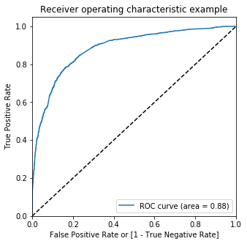

The area under ROC curve is 0.88 which is a very good value

In [91]:

*# Creating columns with different probability cutoffs* numbers **=** [float(x)**/**10 **for** x **in** range(10)]**for** i **in** numbers:

y_train_pred_final[i]**=** y_train_pred_final**.**Conversion_Prob**.**map(**lambda** x: 1 **if** x **>** i **else** 0)y_train_pred_final**.**head()

Out[91]:

|  | **Converted** | **Conversion_Prob** | **Predicted** | **0.0** | **0.1** | **0.2** | **0.3** | **0.4** | **0.5** | **0.6** | **0.7** | **0.8** | **0.9** |
| --- | --- | --- | --- | --- | --- | --- | --- | --- | --- | --- | --- | --- | --- |
| **0** | 0 | 0.257438 | 0 | 1 | 1 | 1 | 0 | 0 | 0 | 0 | 0 | 0 | 0 |
| **1** | 1 | 0.997225 | 1 | 1 | 1 | 1 | 1 | 1 | 1 | 1 | 1 | 1 | 1 |
| **2** | 1 | 0.327989 | 0 | 1 | 1 | 1 | 1 | 0 | 0 | 0 | 0 | 0 | 0 |
| **3** | 0 | 0.259734 | 0 | 1 | 1 | 1 | 0 | 0 | 0 | 0 | 0 | 0 | 0 |
| **4** | 0 | 0.135660 | 0 | 1 | 1 | 0 | 0 | 0 | 0 | 0 | 0 | 0 | 0 |

In [92]:

*# Creating a dataframe to see the values of accuracy, sensitivity, and specificity at different values of probabiity cutoffs*cutoff_df **=** pd**.**DataFrame( columns **=** ['prob','accuracy','sensi','speci'])*# Making confusing matrix to find values of sensitivity, accurace and specificity for each level of probablity***from** sklearn.metrics **import** confusion_matrixnum **=** [0.0,0.1,0.2,0.3,0.4,0.5,0.6,0.7,0.8,0.9]**for** i **in** num:

cm1 **=** metrics**.**confusion_matrix(y_train_pred_final**.**Converted, y_train_pred_final[i] )

total1**=**sum(sum(cm1))

accuracy **=** (cm1[0,0]**+**cm1[1,1])**/**total1

speci **=** cm1[0,0]**/**(cm1[0,0]**+**cm1[0,1])

sensi **=** cm1[1,1]**/**(cm1[1,0]**+**cm1[1,1])

cutoff_df**.**loc[i] **=**[ i ,accuracy,sensi,speci]cutoff_df

Out[92]:

|  | **prob** | **accuracy** | **sensi** | **speci** |
| --- | --- | --- | --- | --- |
| **0.0** | 0.0 | 0.377880 | 1.000000 | 0.000000 |
| **0.1** | 0.1 | 0.605911 | 0.961312 | 0.390038 |
| **0.2** | 0.2 | 0.757508 | 0.907906 | 0.666156 |
| **0.3** | 0.3 | 0.801367 | 0.829689 | 0.784163 |
| **0.4** | 0.4 | 0.817257 | 0.770395 | 0.845722 |
| **0.5** | 0.5 | 0.818211 | 0.702271 | 0.888633 |
| **0.6** | 0.6 | 0.794057 | 0.573591 | 0.927969 |
| **0.7** | 0.7 | 0.782616 | 0.501682 | 0.953257 |
| **0.8** | 0.8 | 0.763547 | 0.421362 | 0.971392 |
| **0.9** | 0.9 | 0.717623 | 0.269975 | 0.989527 |

In [93]:

*# Plotting it*cutoff_df**.**plot**.**line(x**=**'prob', y**=**['accuracy','sensi','speci'])plt**.**show()

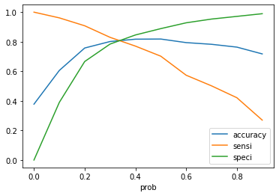

From the graph it is visible that the optimal cut off is at 0.35.

In [136]:

y_train_pred_final['final_predicted'] **=** y_train_pred_final**.**Conversion_Prob**.**map( **lambda** x: 1 **if** x **>** 0.35 **else** 0)y_train_pred_final**.**head()

Out[136]:

|  | **Converted** | **Conversion_Prob** | **Predicted** | **0.0** | **0.1** | **0.2** | **0.3** | **0.4** | **0.5** | **0.6** | **0.7** | **0.8** | **0.9** | **final_predicted** |
| --- | --- | --- | --- | --- | --- | --- | --- | --- | --- | --- | --- | --- | --- | --- |
| **0** | 0 | 0.257438 | 0 | 1 | 1 | 1 | 0 | 0 | 0 | 0 | 0 | 0 | 0 | 0 |
| **1** | 1 | 0.997225 | 1 | 1 | 1 | 1 | 1 | 1 | 1 | 1 | 1 | 1 | 1 | 1 |
| **2** | 1 | 0.327989 | 0 | 1 | 1 | 1 | 1 | 0 | 0 | 0 | 0 | 0 | 0 | 0 |
| **3** | 0 | 0.259734 | 0 | 1 | 1 | 1 | 0 | 0 | 0 | 0 | 0 | 0 | 0 | 0 |
| **4** | 0 | 0.135660 | 0 | 1 | 1 | 0 | 0 | 0 | 0 | 0 | 0 | 0 | 0 | 0 |

In [137]:

*# Check the overall accuracy*metrics**.**accuracy_score(y_train_pred_final**.**Converted, y_train_pred_final**.**final_predicted)

Out[137]:

0.8091530271730494

In [138]:

*# Creating confusion matrix* confusion2 **=** metrics**.**confusion_matrix(y_train_pred_final**.**Converted, y_train_pred_final**.**final_predicted )confusion2

Out[138]:

array([[3191, 724],

[ 477, 1901]], dtype=int64)

In [139]:

*# Substituting the value of true positive*TP **=** confusion2[1,1]*# Substituting the value of true negatives*TN **=** confusion2[0,0]*# Substituting the value of false positives*FP **=** confusion2[0,1] *# Substituting the value of false negatives*FN **=** confusion2[1,0]

In [140]:

*# Calculating the sensitivity*TP**/**(TP**+**FN)

Out[140]:

0.7994112699747687

In [141]:

*# Calculating the specificity*TN**/**(TN**+**FP)

Out[141]:

0.8150702426564496

With the current cut off as 0.35 we have accuracy, sensitivity and specificity of around 80%

## Prediction on Test set

In [100]:

*#Scaling numeric values*X_test[['TotalVisits', 'Page Views Per Visit', 'Total Time Spent on Website']] **=** scaler**.**transform(X_test[['TotalVisits', 'Page Views Per Visit', 'Total Time Spent on Website']])

In [101]:

col **=** X_train**.**columns

In [102]:

*# Select the columns in X_train for X_test as well*X_test **=** X_test[col]*# Add a constant to X_test*X_test_sm **=** sm**.**add_constant(X_test[col])X_test_smX_test_sm

Out[102]:

|  | **const** | **TotalVisits** | **Total Time Spent on Website** | **Lead Origin_Lead Add Form** | **Lead Source_Direct Traffic** | **Lead Source_Google** | **Lead Source_Organic Search** | **Lead Source_Referral Sites** | **Lead Source_Welingak Website** | **Do Not Email_Yes** | **Last Activity_Email Bounced** | **Last Activity_Olark Chat Conversation** | **What is your current occupation_Working Professional** | **Last Notable Activity_Email Link Clicked** | **Last Notable Activity_Email Opened** | **Last Notable Activity_Modified** | **Last Notable Activity_Olark Chat Conversation** | **Last Notable Activity_Page Visited on Website** |
| --- | --- | --- | --- | --- | --- | --- | --- | --- | --- | --- | --- | --- | --- | --- | --- | --- | --- | --- |
| **3308** | 1.0 | 0.117647 | 0.050176 | 0 | 0 | 1 | 0 | 0 | 0 | 0 | 0 | 0 | 0 | 0 | 1 | 0 | 0 | 0 |
| **4421** | 1.0 | 0.000000 | 0.000000 | 0 | 0 | 0 | 0 | 0 | 0 | 0 | 0 | 0 | 0 | 0 | 0 | 0 | 0 | 0 |
| **8855** | 1.0 | 0.058824 | 0.547975 | 0 | 1 | 0 | 0 | 0 | 0 | 0 | 0 | 0 | 0 | 0 | 0 | 1 | 0 | 0 |
| **5302** | 1.0 | 0.000000 | 0.000000 | 0 | 0 | 0 | 0 | 0 | 0 | 0 | 0 | 1 | 0 | 0 | 0 | 1 | 0 | 0 |
| **2169** | 1.0 | 0.588235 | 0.390405 | 0 | 1 | 0 | 0 | 0 | 0 | 0 | 0 | 0 | 0 | 0 | 1 | 0 | 0 | 0 |
| **...** | ... | ... | ... | ... | ... | ... | ... | ... | ... | ... | ... | ... | ... | ... | ... | ... | ... | ... |
| **5655** | 1.0 | 0.058824 | 0.218310 | 0 | 1 | 0 | 0 | 0 | 0 | 0 | 0 | 0 | 0 | 0 | 0 | 1 | 0 | 0 |
| **7836** | 1.0 | 0.588235 | 0.227113 | 0 | 0 | 1 | 0 | 0 | 0 | 0 | 0 | 0 | 1 | 1 | 0 | 0 | 0 | 0 |
| **8378** | 1.0 | 0.588235 | 0.179577 | 0 | 0 | 0 | 1 | 0 | 0 | 1 | 0 | 0 | 0 | 0 | 0 | 0 | 0 | 1 |
| **1263** | 1.0 | 0.117647 | 0.376320 | 0 | 1 | 0 | 0 | 0 | 0 | 0 | 0 | 0 | 1 | 0 | 0 | 0 | 0 | 0 |
| **8633** | 1.0 | 0.058824 | 0.150088 | 0 | 1 | 0 | 0 | 0 | 0 | 1 | 1 | 0 | 0 | 0 | 0 | 1 | 0 | 0 |

2698 rows × 18 columns

In [103]:

*# Storing prediction of test set in the variable 'y_test_pred'*y_test_pred **=** res**.**predict(X_test_sm)*# Coverting it to df*y_pred_df **=** pd**.**DataFrame(y_test_pred)*# Converting y_test to dataframe*y_test_df **=** pd**.**DataFrame(y_test)*# Remove index for both dataframes to append them side by side* y_pred_df**.**reset_index(drop**=True**, inplace**=True**)y_test_df**.**reset_index(drop**=True**, inplace**=True**)*# Append y_test_df and y_pred_df*y_pred_final **=** pd**.**concat([y_test_df, y_pred_df],axis**=**1)*# Renaming column* y_pred_final**=** y_pred_final**.**rename(columns **=** {0 : 'Conversion_Prob'})y_pred_final**.**head()

Out[103]:

|  | **Converted** | **Conversion_Prob** |
| --- | --- | --- |
| **0** | 0 | 0.123887 |
| **1** | 1 | 0.588440 |
| **2** | 1 | 0.370721 |
| **3** | 0 | 0.060348 |
| **4** | 0 | 0.442248 |

In [104]:

*# Making prediction using cut off 0.35*y_pred_final['final_predicted'] **=** y_pred_final**.**Conversion_Prob**.**map(**lambda** x: 1 **if** x **>** 0.35 **else** 0)y_pred_final

Out[104]:

|  | **Converted** | **Conversion_Prob** | **final_predicted** |
| --- | --- | --- | --- |
| **0** | 0 | 0.123887 | 0 |
| **1** | 1 | 0.588440 | 1 |
| **2** | 1 | 0.370721 | 1 |
| **3** | 0 | 0.060348 | 0 |
| **4** | 0 | 0.442248 | 1 |
| **...** | ... | ... | ... |
| **2693** | 1 | 0.111744 | 0 |
| **2694** | 1 | 0.829332 | 1 |
| **2695** | 0 | 0.039085 | 0 |
| **2696** | 1 | 0.965347 | 1 |
| **2697** | 0 | 0.007473 | 0 |

2698 rows × 3 columns

In [105]:

*# Check the overall accuracy*metrics**.**accuracy_score(y_pred_final['Converted'], y_pred_final**.**final_predicted)

Out[105]:

0.8002223869532987

In [106]:

*# Creating confusion matrix* confusion2 **=** metrics**.**confusion_matrix(y_pred_final['Converted'], y_pred_final**.**final_predicted )confusion2

Out[106]:

array([[1350, 327],

[ 212, 809]], dtype=int64)

In [107]:

*# Substituting the value of true positive*TP **=** confusion2[1,1]*# Substituting the value of true negatives*TN **=** confusion2[0,0]*# Substituting the value of false positives*FP **=** confusion2[0,1] *# Substituting the value of false negatives*FN **=** confusion2[1,0]

In [108]:

*# Calculating the sensitivity*TP**/**(TP**+**FN)

Out[108]:

0.7923604309500489

In [109]:

*# Calculating the specificity*TN**/**(TN**+**FP)

Out[109]:

0.8050089445438283

With the current cut off as 0.35 we have accuracy, sensitivity and specificity of around 80%

## Precision-Recall

In [110]:

confusion **=** metrics**.**confusion_matrix(y_train_pred_final**.**Converted, y_train_pred_final**.**Predicted )confusion

Out[110]:

array([[3479, 436],

[ 708, 1670]], dtype=int64)

In [111]:

*# Precision = TP / TP + FP*confusion[1,1]**/**(confusion[0,1]**+**confusion[1,1])

Out[111]:

0.7929724596391263

In [112]:

*#Recall = TP / TP + FN*confusion[1,1]**/**(confusion[1,0]**+**confusion[1,1])

Out[112]:

0.7022708158116064

With the current cut off as 0.35 we have Precision around 79% and Recall around 70%

### Precision and recall tradeoff

In [113]:

**from** sklearn.metrics **import** precision_recall_curve

In [114]:

y_train_pred_final**.**Converted, y_train_pred_final**.**Predicted

Out[114]:

(0 0

1 1

2 1

3 0

4 0

..

6288 1

6289 1

6290 1

6291 0

6292 1

Name: Converted, Length: 6293, dtype: int64,

0 0

1 1

2 0

3 0

4 0

..

6288 1

6289 0

6290 1

6291 0

6292 1

Name: Predicted, Length: 6293, dtype: int64)

In [115]:

p, r, thresholds **=** precision_recall_curve(y_train_pred_final**.**Converted, y_train_pred_final**.**Conversion_Prob)

In [116]:

plt**.**plot(thresholds, p[:**-**1], "g-")plt**.**plot(thresholds, r[:**-**1], "r-")plt**.**show()

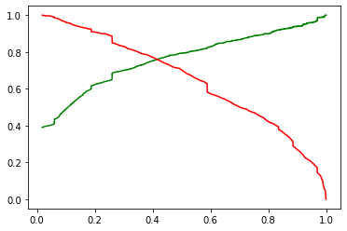

In [117]:

y_train_pred_final['final_predicted'] **=** y_train_pred_final**.**Conversion_Prob**.**map(**lambda** x: 1 **if** x **>** 0.41 **else** 0)y_train_pred_final**.**head()

Out[117]:

|  | **Converted** | **Conversion_Prob** | **Predicted** | **0.0** | **0.1** | **0.2** | **0.3** | **0.4** | **0.5** | **0.6** | **0.7** | **0.8** | **0.9** | **final_predicted** |
| --- | --- | --- | --- | --- | --- | --- | --- | --- | --- | --- | --- | --- | --- | --- |
| **0** | 0 | 0.257438 | 0 | 1 | 1 | 1 | 0 | 0 | 0 | 0 | 0 | 0 | 0 | 0 |
| **1** | 1 | 0.997225 | 1 | 1 | 1 | 1 | 1 | 1 | 1 | 1 | 1 | 1 | 1 | 1 |
| **2** | 1 | 0.327989 | 0 | 1 | 1 | 1 | 1 | 0 | 0 | 0 | 0 | 0 | 0 | 0 |
| **3** | 0 | 0.259734 | 0 | 1 | 1 | 1 | 0 | 0 | 0 | 0 | 0 | 0 | 0 | 0 |
| **4** | 0 | 0.135660 | 0 | 1 | 1 | 0 | 0 | 0 | 0 | 0 | 0 | 0 | 0 | 0 |

In [118]:

*# Accuracy*metrics**.**accuracy_score(y_train_pred_final**.**Converted, y_train_pred_final**.**final_predicted)

Out[118]:

0.8180518035912919

In [119]:

*# Creating confusion matrix again*confusion2 **=** metrics**.**confusion_matrix(y_train_pred_final**.**Converted, y_train_pred_final**.**final_predicted )confusion2

Out[119]:

array([[3333, 582],

[ 563, 1815]], dtype=int64)

In [120]:

*# Substituting the value of true positive*TP **=** confusion2[1,1]*# Substituting the value of true negatives*TN **=** confusion2[0,0]*# Substituting the value of false positives*FP **=** confusion2[0,1] *# Substituting the value of false negatives*FN **=** confusion2[1,0]

In [121]:

*# Precision = TP / TP + FP*TP **/** (TP **+** FP)

Out[121]:

0.7571964956195244

In [122]:

*#Recall = TP / TP + FN*TP **/** (TP **+** FN)

Out[122]:

0.763246425567704

With the current cut off as 0.44 we have Precision around 76% and Recall around 76.3% and accuracy 82 %.

## Prediction on Test set

In [123]:

*# Storing prediction of test set in the variable 'y_test_pred'*y_test_pred **=** res**.**predict(X_test_sm)*# Coverting it to df*y_pred_df **=** pd**.**DataFrame(y_test_pred)*# Converting y_test to dataframe*y_test_df **=** pd**.**DataFrame(y_test)*# Remove index for both dataframes to append them side by side* y_pred_df**.**reset_index(drop**=True**, inplace**=True**)y_test_df**.**reset_index(drop**=True**, inplace**=True**)*# Append y_test_df and y_pred_df*y_pred_final **=** pd**.**concat([y_test_df, y_pred_df],axis**=**1)*# Renaming column* y_pred_final**=** y_pred_final**.**rename(columns **=** {0 : 'Conversion_Prob'})y_pred_final**.**head()

Out[123]:

|  | **Converted** | **Conversion_Prob** |
| --- | --- | --- |
| **0** | 0 | 0.123887 |
| **1** | 1 | 0.588440 |
| **2** | 1 | 0.370721 |
| **3** | 0 | 0.060348 |
| **4** | 0 | 0.442248 |

In [124]:

*# Making prediction using cut off 0.41*y_pred_final['final_predicted'] **=** y_pred_final**.**Conversion_Prob**.**map(**lambda** x: 1 **if** x **>** 0.44 **else** 0)y_pred_final

Out[124]:

|  | **Converted** | **Conversion_Prob** | **final_predicted** |
| --- | --- | --- | --- |
| **0** | 0 | 0.123887 | 0 |
| **1** | 1 | 0.588440 | 1 |
| **2** | 1 | 0.370721 | 0 |
| **3** | 0 | 0.060348 | 0 |
| **4** | 0 | 0.442248 | 1 |
| **...** | ... | ... | ... |
| **2693** | 1 | 0.111744 | 0 |
| **2694** | 1 | 0.829332 | 1 |
| **2695** | 0 | 0.039085 | 0 |
| **2696** | 1 | 0.965347 | 1 |
| **2697** | 0 | 0.007473 | 0 |

2698 rows × 3 columns

### Check the overall accuracy

In [125]:

*# Check the overall accuracy*metrics**.**accuracy_score(y_pred_final['Converted'], y_pred_final**.**final_predicted)

Out[125]:

0.8057820607857672

In [126]:

*# Creating confusion matrix* confusion2 **=** metrics**.**confusion_matrix(y_pred_final['Converted'], y_pred_final**.**final_predicted )confusion2

Out[126]:

array([[1426, 251],

[ 273, 748]], dtype=int64)

In [127]:

*# Substituting the value of true positive*TP **=** confusion2[1,1]*# Substituting the value of true negatives*TN **=** confusion2[0,0]*# Substituting the value of false positives*FP **=** confusion2[0,1] *# Substituting the value of false negatives*FN **=** confusion2[1,0]

In [128]:

*# Precision = TP / TP + FP*TP **/** (TP **+** FP)

Out[128]:

0.7487487487487487

In [129]:

*#Recall = TP / TP + FN*TP **/** (TP **+** FN)

Out[129]:

0.732615083251714

With the current cut off as 0.41 we have Precision around 75% , Recall around 73% and accuracy 80.5%.

The Model seems to predict the Conversion Rate very well and we should be able to give the CEO confidence in making good calls based on this model

# Conclusion

It was found that the variables that mattered the most in the potential buyers are (In descending order) :

# TotalVisits

# The total time spend on the Website.

# Lead Origin_Lead Add Form

# Lead Source_Direct Traffic

# Lead Source_Google

# Lead Source_Welingak Website

# Lead Source_Organic Search

# Lead Source_Referral Sites

# Lead Source_Welingak Website

# Do Not Email_Yes

# Last Activity_Email Bounced

# Last Activity_Olark Chat

# Conversation

### Keeping these in mind the X Education can flourish as they have a very high chance to get almost all the potential buyers to change their mind and buy their courses.